Objective Questions

- List the different types of columns in table “ball_by_ball” (using information schema)
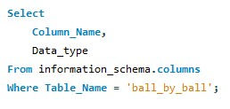
Output:
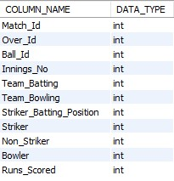
- What is the total number of runs scored in 1st season by RCB (bonus: also include the extra runs using the extra runs table)
The team RCB scored 2601 runs in the 6th season (minimum season available within ball_by_ball data) i.e, in the year 2013.
Approach:
Every Batsman Scored runs are found in the ball_by_ball table. Every extra run for an extra ball is available in the extra_runs table.
Combined both of them on the basis of their primary keys( match_id, innings_no, over_id, ball_id)

The team and season filters are applied in Where condition using information from Matches and Team tables.
Then used coalesce to deal with nulls disrupting the Sum Calculation
Query:
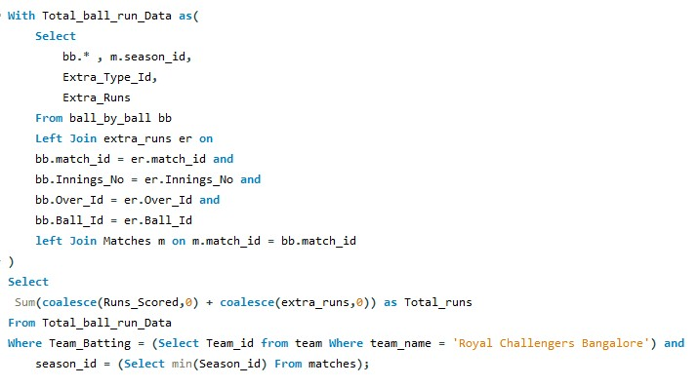
Output:
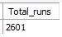
- How many players were more than the age of 25 during season 2014?
There are 92 players with age more than 25, as per the last match they played in the 2014 season.
Approach:
We first filtered out the Matches table, to get only matches from 2014 season.
We then did an inner join of 2014_Match Data with Player_Match to get players and the matches they played in 2014.
We further summarized the table by grouping by each player and picking the last match_date they played in 2014 as 2014_Player_Data
Now we joined the player table to access the birthdays. And then using timestampdiff() function, filtered out players who are more than 25 during their last match of 2014 season.
Query:
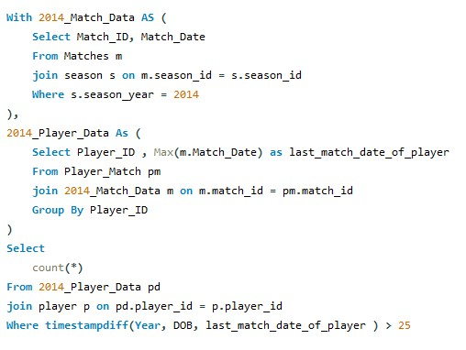
Output:
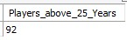
- How many matches did RCB win in 2013?
RCB won 9 matches in 2013.
Approach:
From Matches table filtered using extracted year column from Match Date
Further filtering where Match Winner is RCB using subquery
Query:
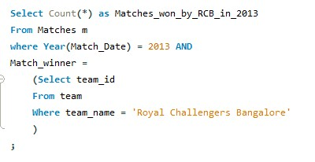
Output:


- List the top 10 players according to their strike rate in the last 4 seasons
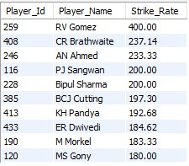
Approach:
To identify the top 10 players based on strike rate in the last four seasons, we first determined the most recent season available in the dataset and calculated a rolling four-season window using a Common Table Expression (CTE).
We then joined the ball-by-ball data with match and season tables to restrict the analysis to only those recent seasons. Since strike rate in cricket is calculated using only legitimate balls faced, deliveries that resulted in extra runs were excluded using a “NOT EXISTS” condition.
For each batsman, the strike rate was computed as the total runs scored per 100 legal balls faced. Finally, the calculated strike rates were joined with the player master table to retrieve player names, and the results were sorted in descending order to list the top 10 players with the highest strike rates in the last four seasons.
Query:
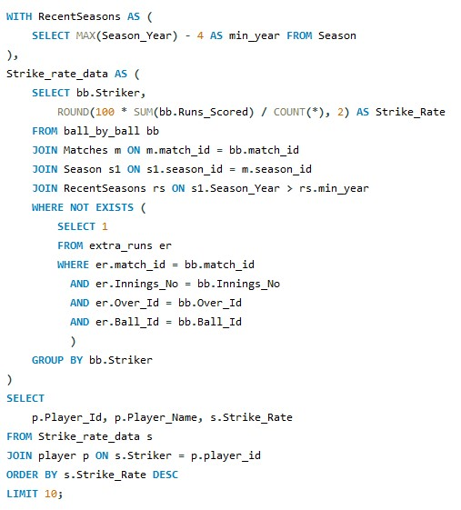
- What are the average runs scored by each batsman considering all the seasons?
Approach:
To calculate the average runs scored by each batsman across all seasons, we first aggregated the total runs scored by each player using ball-by-ball data while excluding deliveries that resulted in extra runs, since only legal balls contribute to a batsman’s performance.
In parallel, we determined how many times each batsman was dismissed by counting their occurrences in the wicket-taken table.

These two datasets were then combined using a left join to ensure that not-out batsmen were also included in the analysis.
The batting average was calculated as total runs divided by the number of dismissals, with a conditional logic applied to handle cases where a batsman was never dismissed, in which case their total runs were used as the average.
Finally, the results were joined with the player master table to retrieve player names and sorted in descending order of average runs to rank the batsmen accordingly.
Query:
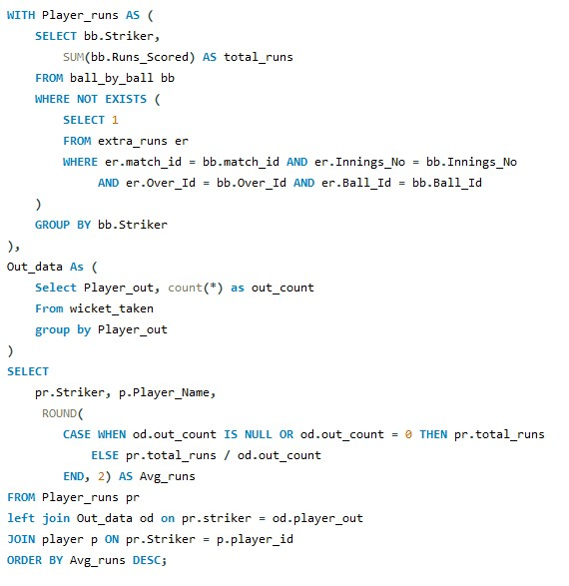
Output:
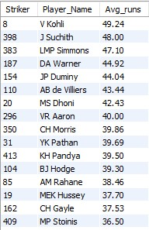
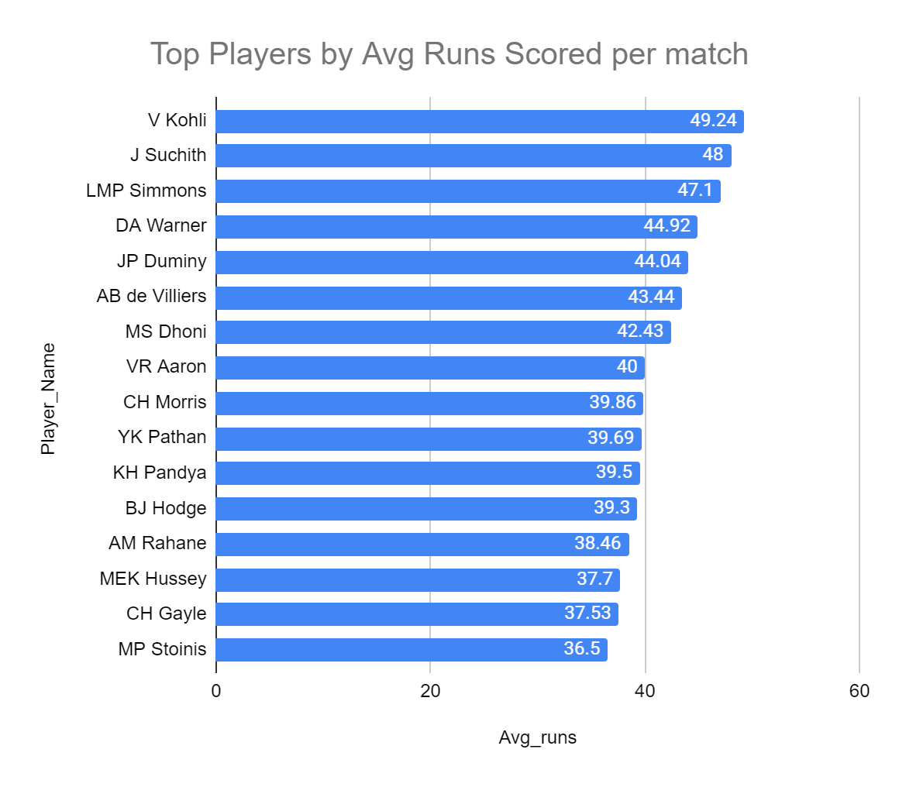

- What are the average wickets taken by each bowler considering all the seasons?
Approach:
To compute the average wickets taken by each bowler across all seasons, wicket-taking events were first extracted from the wicket-taken table and filtered using out_type table to include only dismissals that are directly attributable to the bowler.
These records were accurately joined with ball-by-ball data using match, innings, over, and ball identifiers to correctly assign each wicket to the corresponding bowler.
The data was then aggregated at the season level to calculate the total number of wickets taken by each bowler in every season.
Finally, an average of these season-wise wicket counts was calculated for each bowler to normalize performance across seasons, and player details were joined for readability before ordering the results by average wickets per season.
Query:
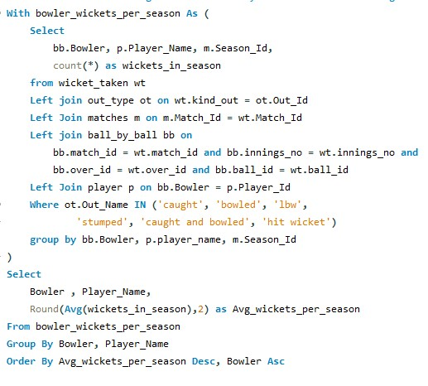

output:
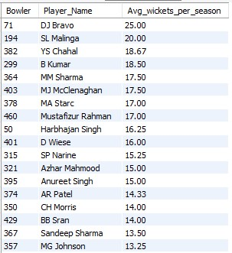
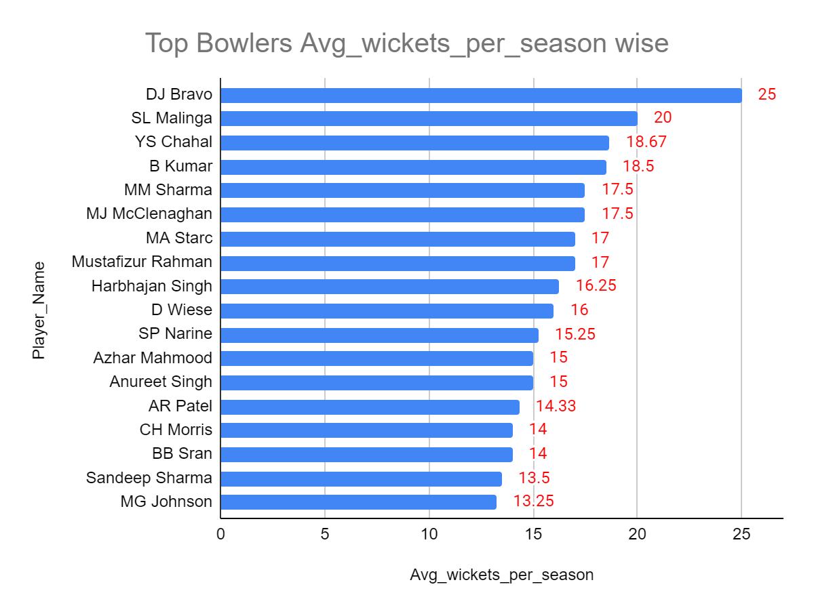
- List all the players who have average runs scored greater than the overall average and who have taken wickets greater than the overall average
Approach:
To identify players who excel in both batting and bowling, the analysis was structured in multiple logical stages using Common Table Expressions (CTEs).
Batting performance was first calculated using the ball_by_ball table by aggregating total runs scored by each batsman, while excluding deliveries that resulted in extra runs through a NOT EXISTS condition on the extra_runs table to ensure only legitimate batting contributions were considered.
The number of times each batsman was dismissed was obtained from the wicket_taken table, and batting averages were computed as total runs divided by dismissals, with conditional handling for players who were never dismissed.
An overall batting benchmark was then established by calculating the average of all individual batting averages.
In parallel, bowling performance was derived by joining the wicket_taken, out_type, and ball_by_ball tables to accurately attribute bowler-credited dismissals such as bowled, caught, lbw, and stumped.
Total wickets taken by each bowler were calculated, followed by the computation of an overall bowling benchmark representing the average wickets taken across all bowlers.
Finally, batting and bowling metrics were combined by joining individual player statistics with the player master table for identification. Players whose batting averages exceeded the overall batting average and whose wicket tallies surpassed the overall bowling average were filtered and ranked.
Output:
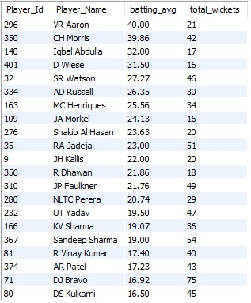

Query:
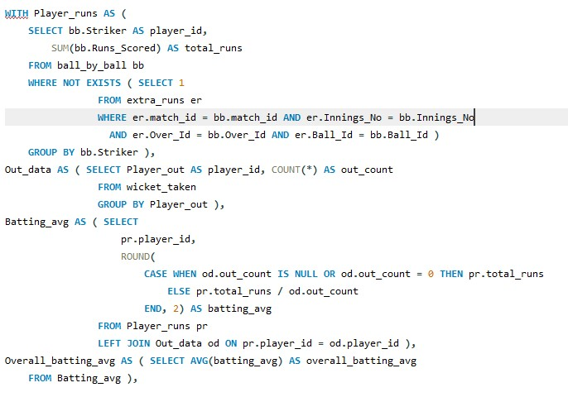
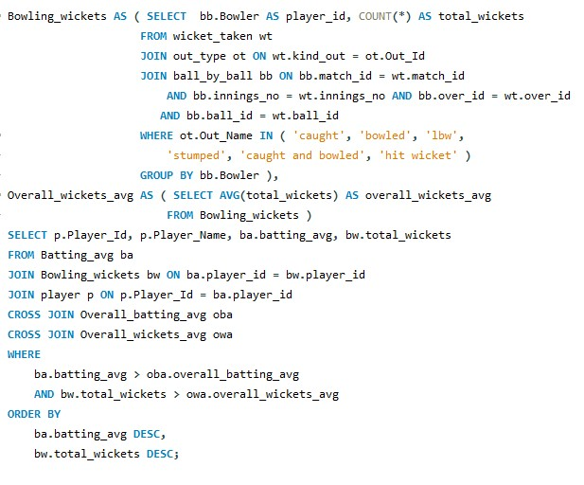
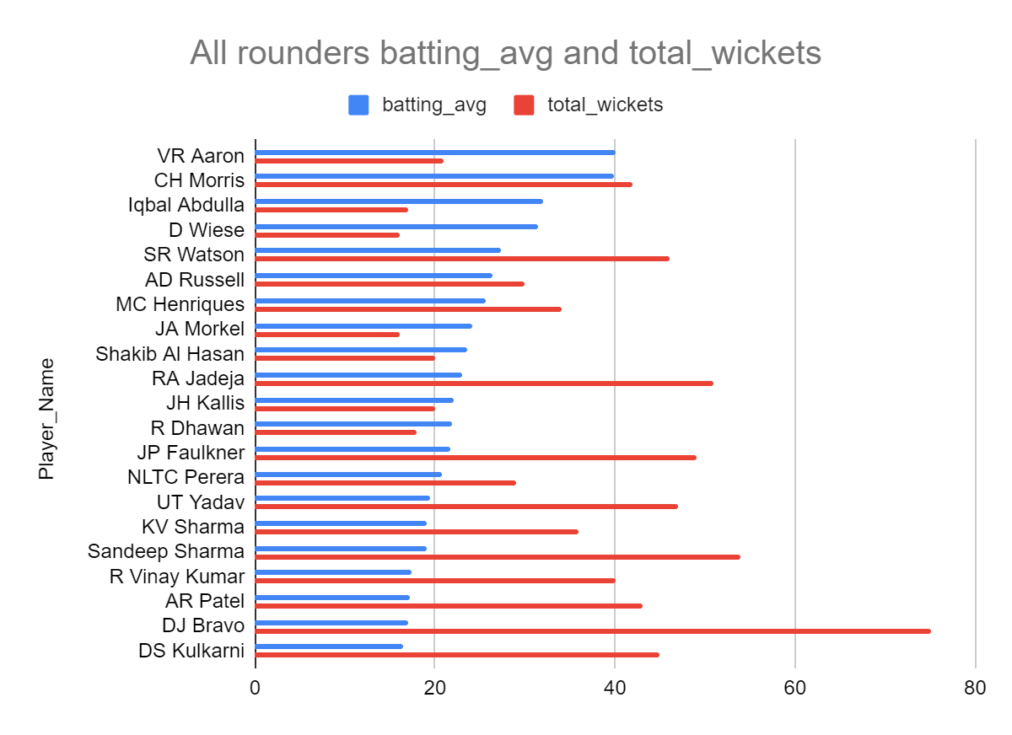
We can see players like Morris, Watson, Russell, Henriques, Jadeja etc perform well both with bat and ball. They are all rounders.

- Create a table rcb_record table that shows the wins and losses of RCB in an individual venue.
To analyze Royal Challengers Bangalore’s win–loss record across different venues, the team identifier for RCB was first isolated using the team table and stored in a Common Table Expression (CTE) for reusability and clarity. Match-level data was then extracted from the matches table and joined with the venue table to associate each match with its corresponding venue. Only matches in which RCB participated were considered by filtering on the team appearing as either team_1 or team_2..
Wins and losses were computed using conditional aggregation based on the match winner. If RCB was recorded as the match winner, the match was counted as a win; otherwise, it was counted as a loss. These conditional counts were aggregated at the venue level to produce total matches played, wins, and losses for RCB at each venue. The final result provides a venue-wise performance summary, enabling easy comparison of RCB’s success rate across different stadiums.

Query:
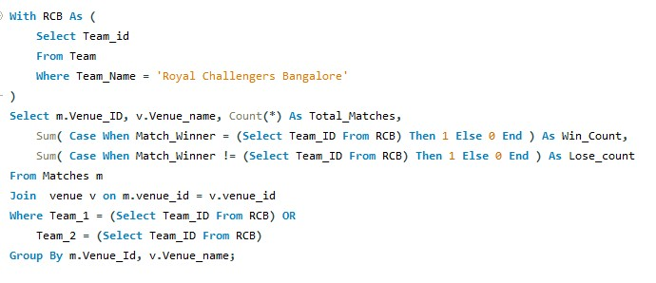
Output:
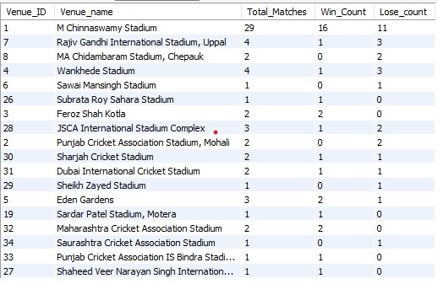

- What is the impact of bowling style on wickets taken?
Approach:
To evaluate the impact of different bowling styles on wickets taken, wicket events were extracted from the wicket_taken table and accurately mapped to individual bowlers using the ball_by_ball table through match, innings, over, and ball identifiers. The bowler information was then joined with the player table to obtain each player’s bowling style, which was further mapped to descriptive style names using the bowling_style reference table.
Wickets were aggregated by bowling style to calculate the total number of wickets taken by each style across all matches and seasons. To assess the relative impact of each bowling style, a window function was used to compute the percentage contribution of wickets taken by each style with respect to the total wickets taken by all styles combined. The results were then ordered in descending order of percentage to highlight the bowling styles that have the greatest overall impact on wicket-taking.
This approach ensures accurate wicket attribution, proper categorization by bowling style, and a normalized comparison of performance across different bowling styles.

Query:
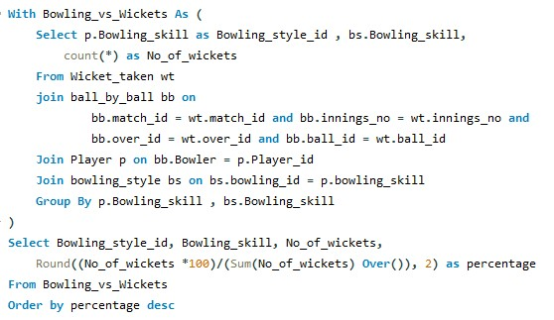

Output:
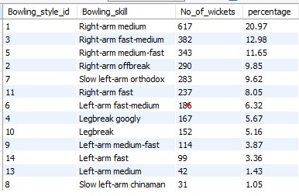

- Write the SQL query to provide a status of whether the performance of the team is better than the previous year's performance on the basis of the number of runs scored by the team in the season and the number of wickets taken
Approach:
To evaluate whether a team’s performance has improved compared to the previous season, the analysis was structured around two core performance metrics: total runs scored and total wickets taken per team per season. First, season-wise batting performance was calculated using the ball_by_ball table, where runs off the bat were combined with extra runs from the extra_runs table to derive the team’s total runs for each season. This ensured that all contributions to the team’s score were accurately captured.
In parallel, bowling performance was measured by counting wickets taken by each team per season using the wicket_taken table, joined with ball_by_ball to correctly associate each wicket with the bowling team and season. Both datasets were linked to the matches table to align performances with the correct season identifiers.
Next, the runs and wickets datasets were merged to create a consolidated team–season performance view, enriched with team names and season years from the team and season reference tables. Window functions (LAG) were then applied, partitioned by team and ordered by season year, to retrieve each team’s runs and wickets from the immediately preceding season.
Finally, a conditional comparison logic was applied to classify performance trends. Teams were labeled as Improved, Decreased, No Change, or Mixed based on whether both metrics increased, decreased, remained the same, or moved in opposite directions relative to the previous season. Records without prior-season data were excluded to ensure valid year-over-year comparisons.
This stepwise approach enables a clear, season-over-season evaluation of team performance using both batting and bowling effectiveness.

Query:

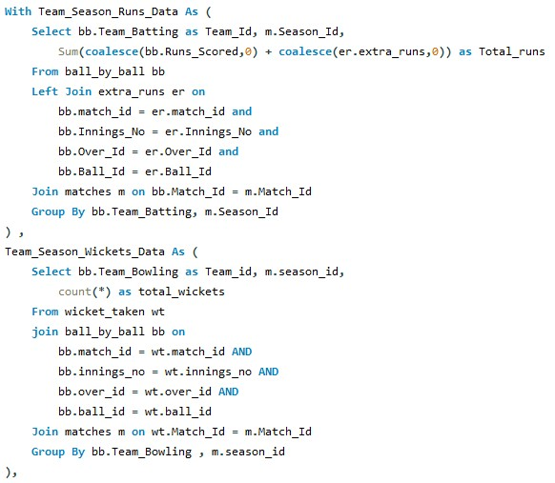
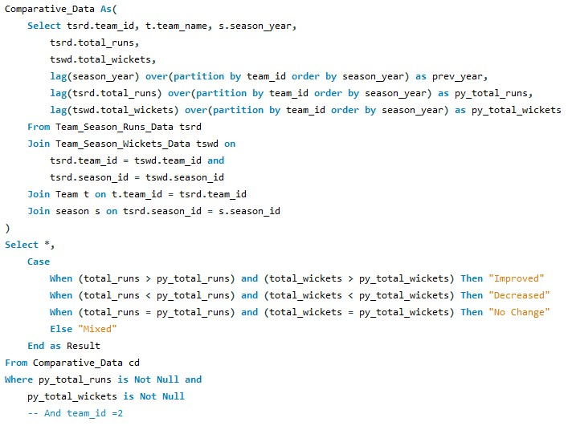
Output:
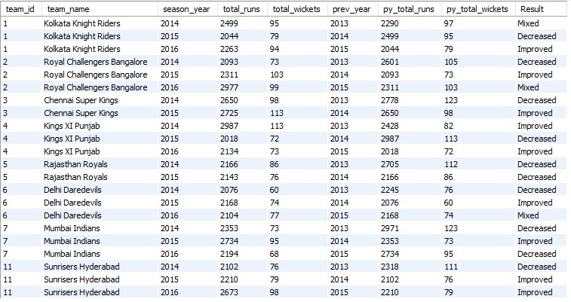
- Can you derive more KPIs for the team strategy?
For a team like Royal Challengers Bangalore (RCB), which has historically been batting-heavy but bowling-inconsistent, the KPIs should:
- Expose structural weaknesses.
- Guide auction & squad decisions.
- Improve match-winning consistency
Here are the Top 5 KPIs I would pick for RCB’s team strategy.
- Runs per Match (Batting Stability KPI)
Formula: Total Runs in Season / Matches Played
RCB often has explosive innings but lacks consistency. This KPI tells, Are we consistently competitive? Or are we relying on 1–2 big knocks?
🔍 Strategy use:
If volatile → need middle-order stability
If low → need better powerplay utilization

Query:
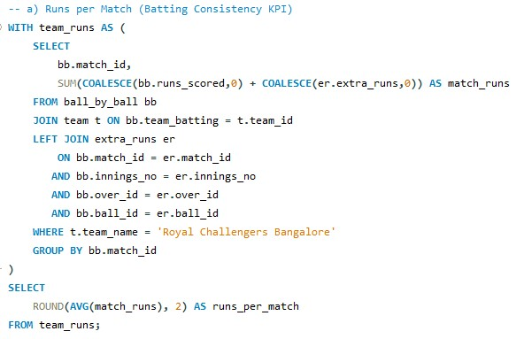
- Wickets per Match (Bowling Firepower KPI)
Formula : Total Wickets in Season / Matches Played
RCB’s biggest weakness historically = taking wickets consistently.
This KPI tells: Can we break partnerships? Do we control the game, or just defend totals?
🔍 Strategy use:
Low → invest in strike bowlers. High → improve run containment

Query:
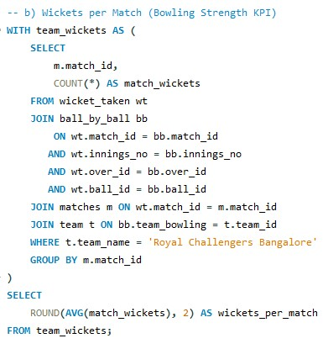
- Dependency Index (Superstar Reliance KPI)
Formula: Runs by Top 3 Batsmen / Total Team Runs
RCB has often been dependent on: Kohli, ABD, Faf, Maxwell, etc.
High dependency = fragile team.
🔍 Strategy use:
High → recruit reliable middle-order.
Low → strong team depth
Query:
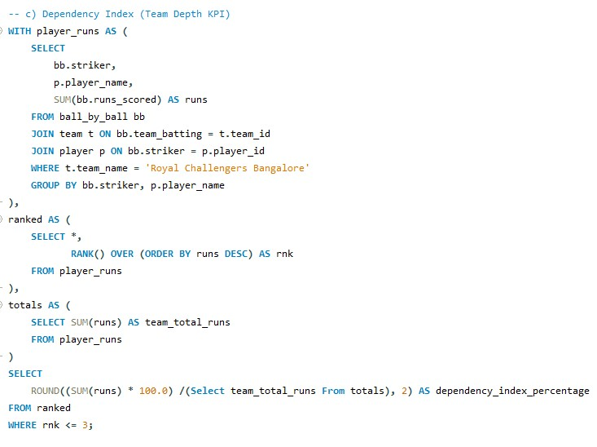
- Death Overs Efficiency (Clutch Performance KPI)
Batting Formula: Avg(runs) scored in Death Overs 16-20
Bowling Formula : Avg(wickets_taken) in overs 16-20
RCB has lost MANY matches in death overs.
This KPI tells: Are we good finishers? Are our death bowlers effective?
🔍 Strategy use:
Weak batting → need finishers
Weak bowling → need yorker specialists
Batting Query: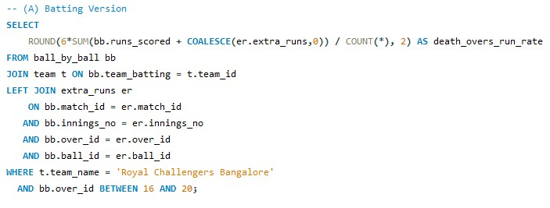
Bowling Query:
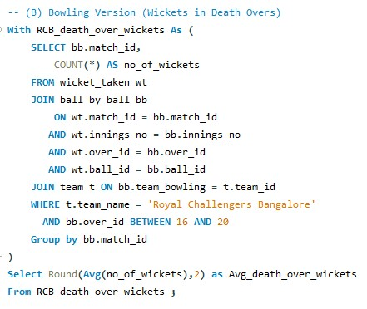

- Net Impact Score (All-Round Strength KPI)
Formula : Net Impact = (Team Runs / League Avg Runs)
+ (Team Wickets / League Avg Wickets)
This single number tells: Are we better or worse than the league?
🔍 Strategy use:
Auction planning.
Long-term team health.
Comparing seasons.
Query:
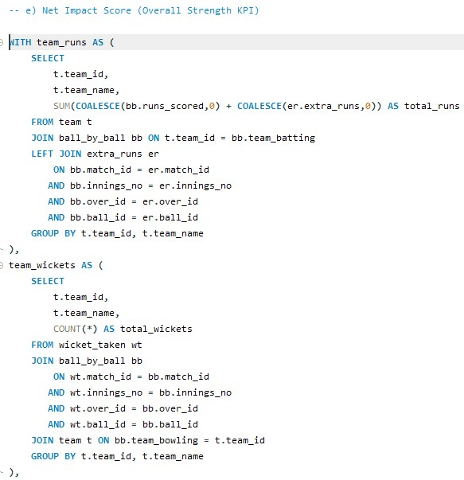
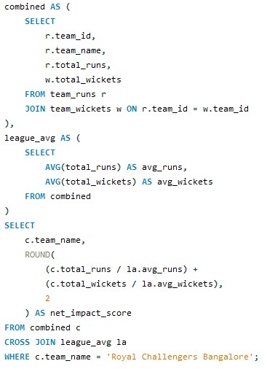

- Using SQL, write a query to find out the average wickets taken by each bowler in each venue. Also, rank them according to the average value.
First, detailed bowler–venue performance data is constructed by joining wicket_taken with ball_by_ball to correctly map each wicket to the bowler, over, and ball. This is further joined with matches to associate wickets with match and venue information, venue to retrieve venue names, player to identify bowlers, and out_type to filter only valid bowling dismissals such as bowled, caught, lbw, stumped, etc. For each bowler–venue combination, the total number of wickets and the number of distinct matches played are calculated. Using these values, the average wickets taken per match at that venue is derived.
Next, a minimum match threshold is applied to ensure statistical reliability. Only bowler–venue combinations with at least five matches are retained, preventing skewed averages due to very small sample sizes.
Finally, a window function (DENSE_RANK) is used to rank bowlers within each venue based on their average wickets taken per match, ordered from highest to lowest. This ranking is partitioned by venue so that bowlers are compared only against others who have played at the same venue.
The final result presents a clear, venue-wise ranking of bowlers based on their average wicket-taking effectiveness, making it easy to identify venue-specific bowling specialists.
Query:
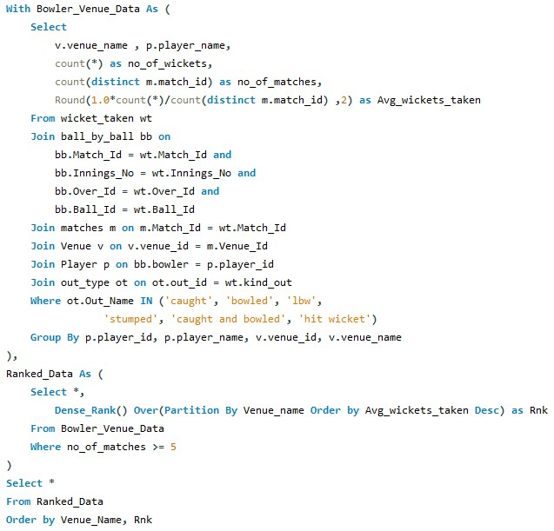

Output:
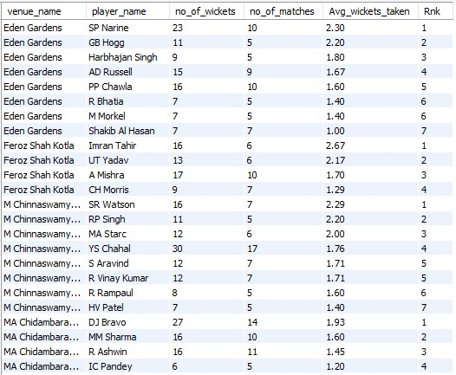
- Which of the given players have consistently performed well in past seasons? (will you use any visualization to solve the problem)

Approach – Batting Consistency Analysis
To identify batsmen who have consistently performed well across past seasons, the analysis begins at the ball-by-ball level, using the ball_by_ball table as the primary source of runs scored. The data is enriched by joining with the matches and season tables to associate each delivery with its corresponding season year, and with the player table to retrieve player names.
To ensure that only legitimate batting runs are considered, deliveries that resulted in extra runs are excluded using a NOT EXISTS subquery on the extra_runs table. Runs are then aggregated at a player–season level, producing total runs scored by each batsman in each season.
In the final step, an average of these season-wise runs is calculated per player using AVG(season_runs), providing a measure of long-term batting consistency rather than performance driven by a single high-scoring season. Players are ranked by this average to highlight those who have maintained strong batting output across multiple seasons.
Query:
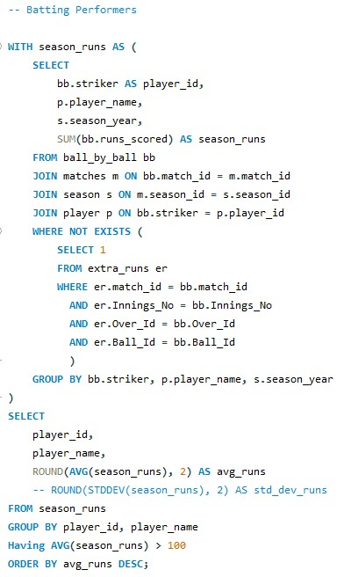
Output:
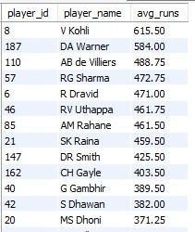
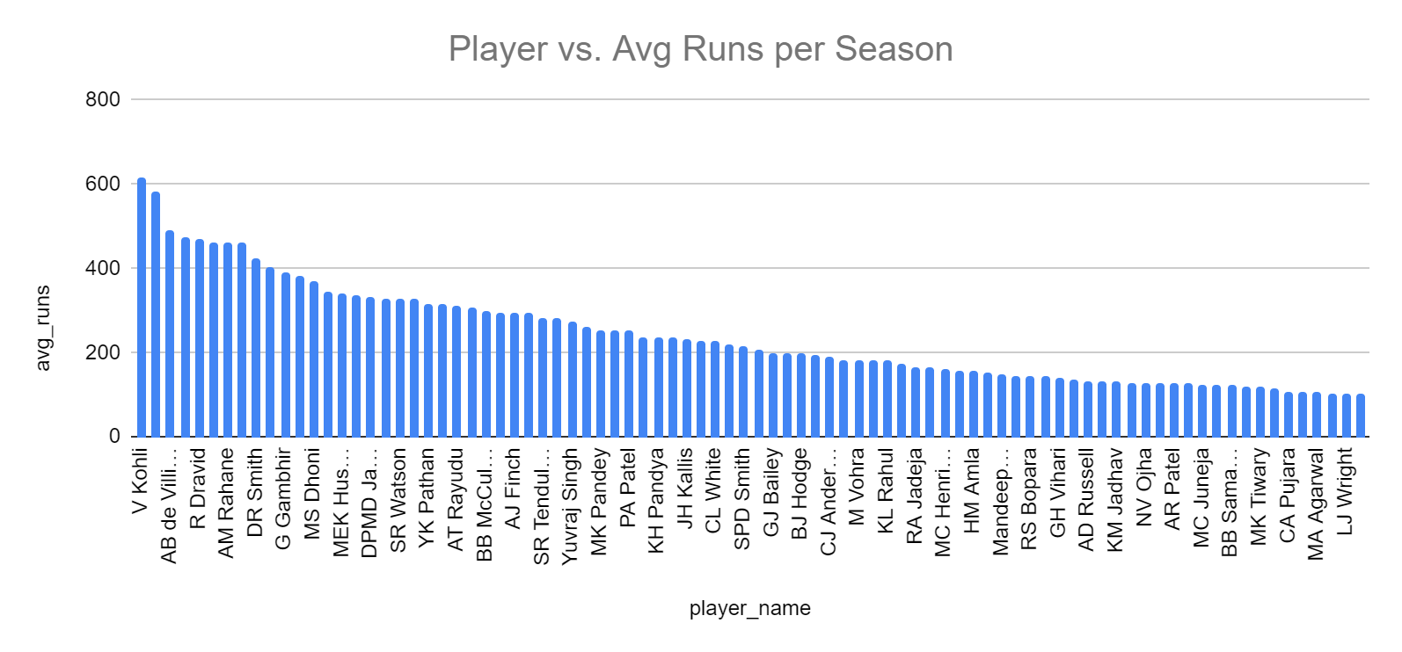

Approach – Bowling Consistency Analysis
To evaluate consistent bowling performance over past seasons, the analysis focuses on wickets taken by bowlers using the wicket_taken table, which captures dismissal events. This table is accurately linked to ball_by_ball using match, innings, over, and ball identifiers to ensure correct bowler attribution.
The data is further filtered by joining with the out_type table and restricting the analysis to genuine bowler-attributed dismissals such as bowled, caught, lbw, stumped, and hit wicket.
Seasonal context is added by joining with the matches and season tables, while player details are obtained from the player table.
Wickets are aggregated at a bowler–season level, resulting in the number of wickets taken by each bowler in each season.
Finally, the average wickets per season are computed for each bowler using AVG(season_wickets), and then applied filter having average as greater than or equal to 10 wickets, which serves as a reliable indicator of bowling consistency over time.
Ordering the results by this average highlights bowlers who have consistently contributed with wickets across multiple seasons rather than excelling in isolated years.

Query:
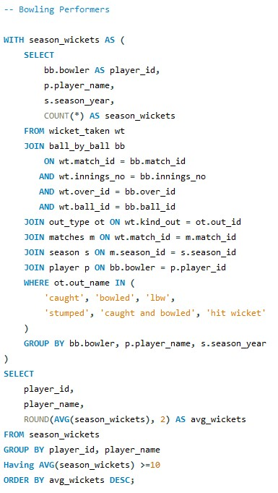

Output:
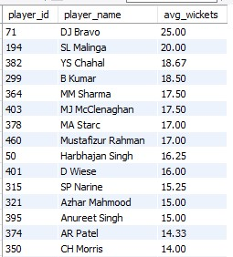
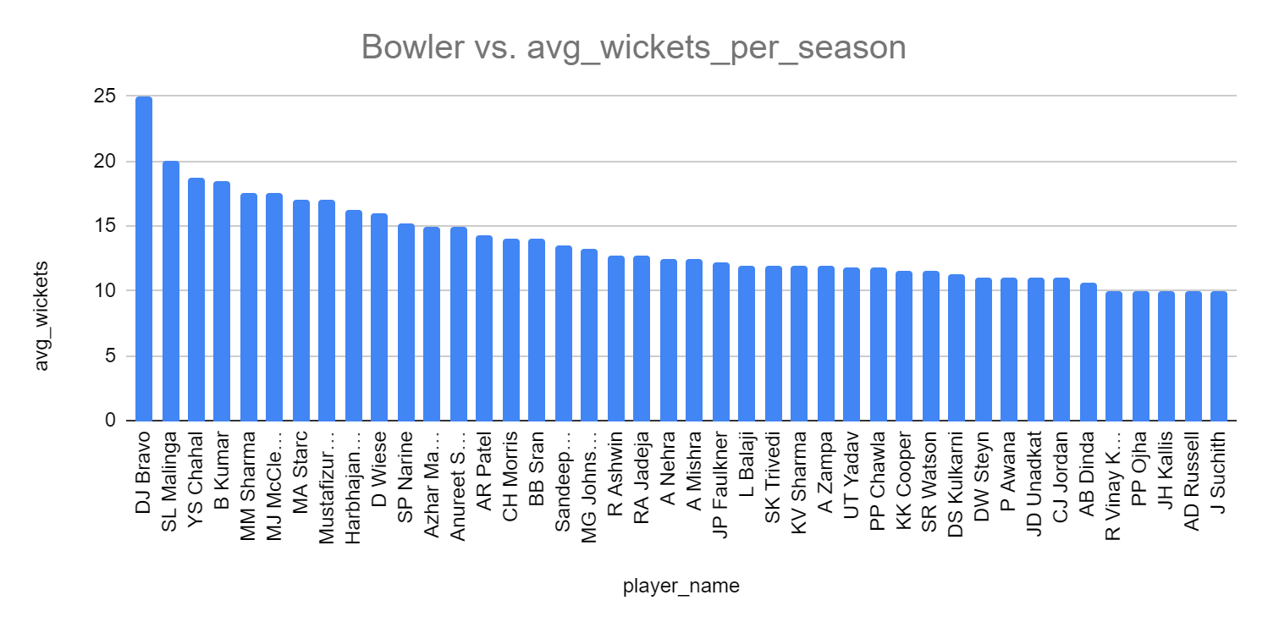

- Are there players whose performance is more suited to specific venues or conditions? (how would you present this using charts?)

Approach – Bowlers: Venue-Specific Performance Analysis
To determine whether certain bowlers are more effective at specific venues, the analysis begins by combining the wicket_taken, ball_by_ball, matches, venue, player, and out_type tables. Only legitimate bowler-attributed dismissals (such as caught, bowled, lbw, stumped, caught and bowled, and hit wicket) are considered to ensure analytical accuracy. For each bowler–venue combination, the total number of wickets and the number of distinct matches played are calculated, allowing the derivation of average wickets per match at that venue. To establish a baseline for comparison, an overall average wickets per match is computed for each bowler across all venues using aggregated wickets and matches. The venue dependency is then quantified using a dependency score, defined as the difference between the venue-specific average and the bowler’s overall average. To maintain statistical reliability, only venues where the bowler has played at least five matches are included. Finally, venues are ranked per bowler using a window function, and the top-ranked venue with a positive dependency score is selected, highlighting venues where the bowler performs significantly better than their overall norm.
Query:
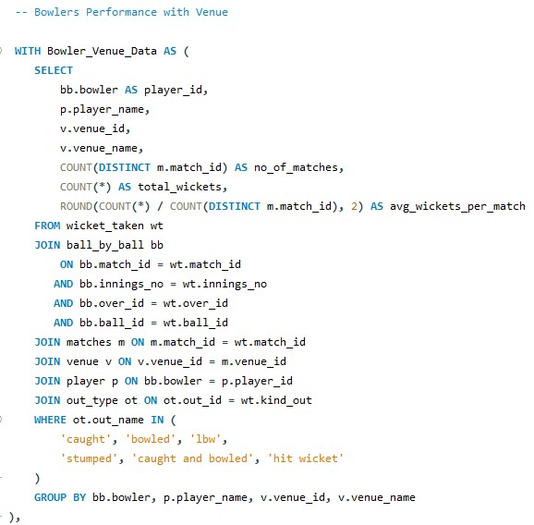
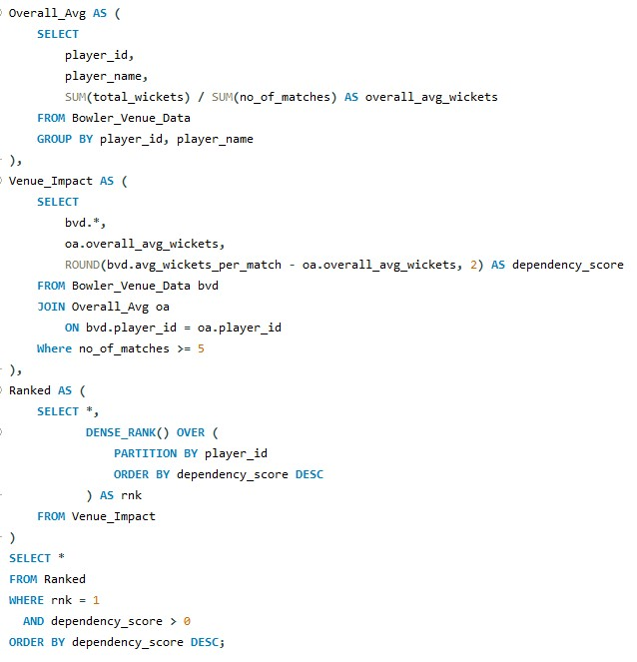
Output:
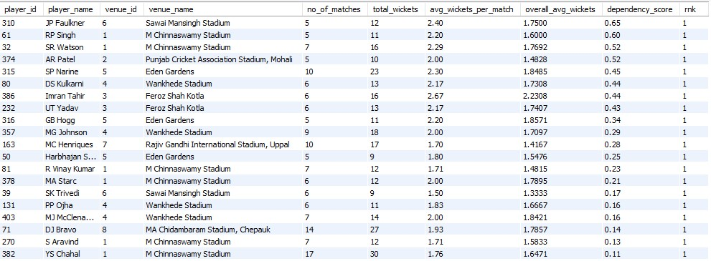

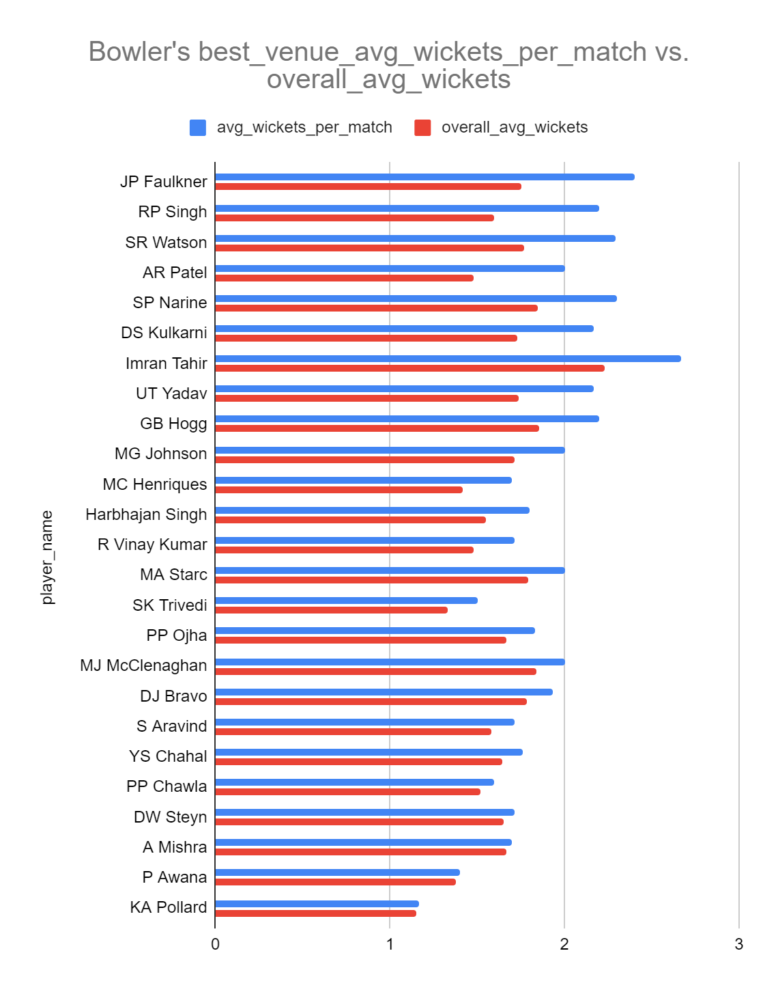

Approach – Batsmen: Venue-Specific Performance Analysis
To assess whether batsmen exhibit stronger performance at particular venues, the analysis uses the ball_by_ball, matches, venue, and player tables as its foundation.
Only runs scored off the bat are included by excluding deliveries associated with extra runs through a NOT EXISTS filter on the extra_runs table.
For each batsman–venue combination, total runs and the number of distinct matches played are aggregated, enabling calculation of average runs per match at each venue.
A minimum threshold of five matches per venue is applied to avoid skewed results from limited appearances.
To contextualize venue performance, an overall average runs per match is calculated for each batsman across all venues using total runs and total matches.
The dependency score is then computed as the difference between the venue-specific average and the overall average, capturing how much better a batsman performs at a particular venue compared to their general performance level.
Using window functions, venues are ranked per batsman based on this dependency score, and the top-ranked venue with a positive score is selected, identifying venues where the batsman is especially well suited.
Query:

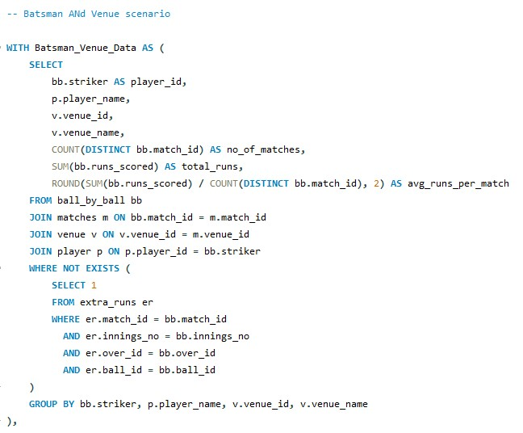
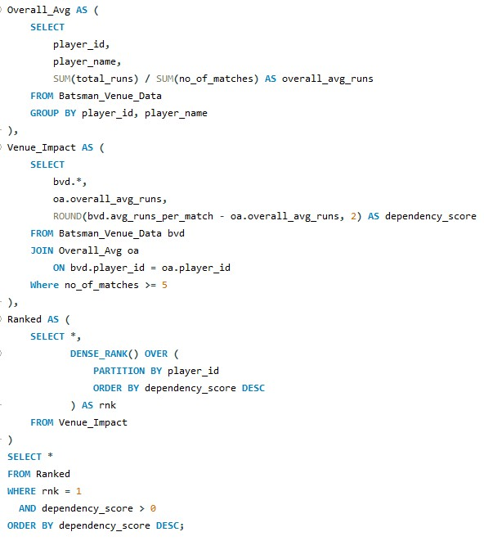

Output:

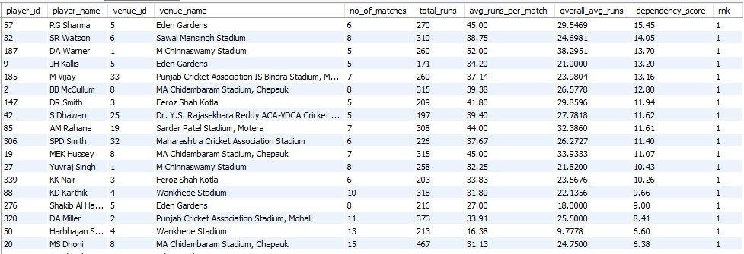
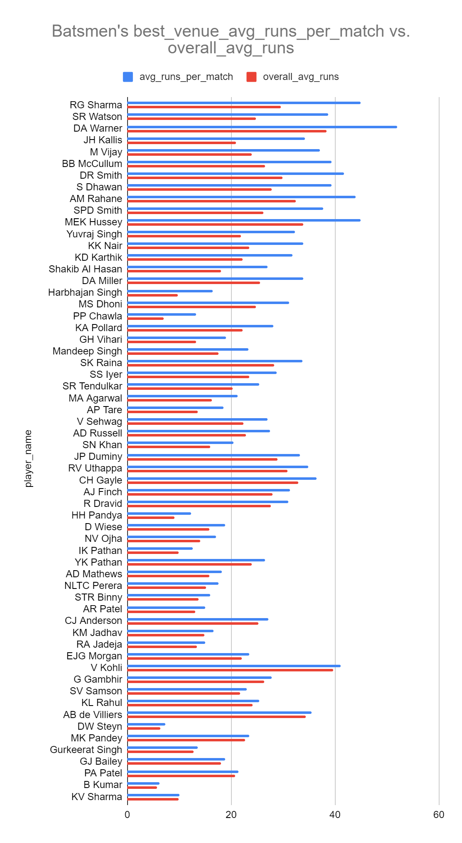
Subjective Questions

- How does the toss decision affect the result of the match? (which visualizations could be used to present your answer better) And is the impact limited to only specific venues?
First, let's see if winning a toss has an impact on winning a match. For that we considered all the matches of all the seasons.
Query:
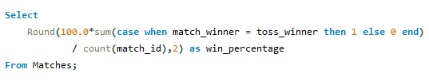
Output:
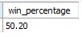
We find that win_percentage is 50.20
It means that in general toss winning doesn’t guarantee match winning.
Let's dive deeper. We create a view to help us in building further analysis.
Query:
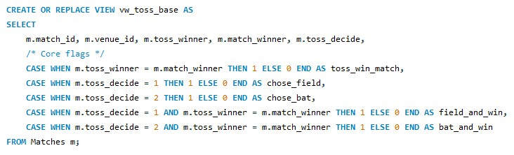
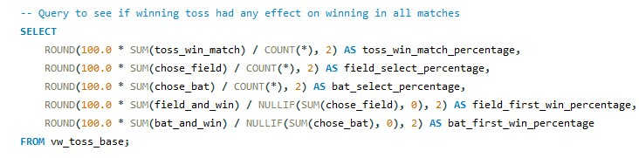
Output:

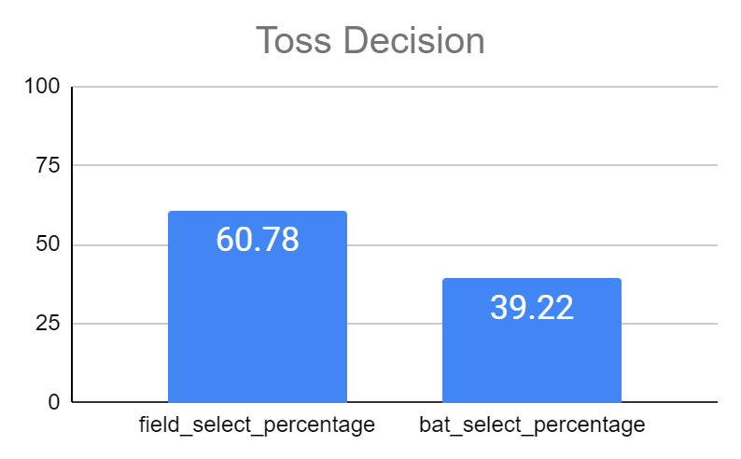
In Majority of Matches, toss_winners decided to field first
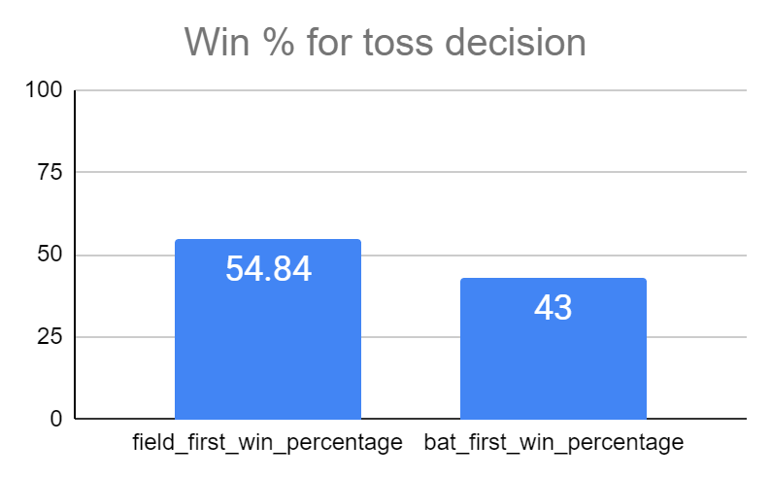
Opting for fielding first has 54.84% chance of winning
& Opting for batting first has a 43% chance of winning.
Query:
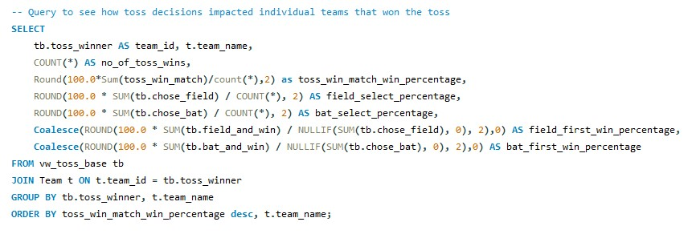

Output:
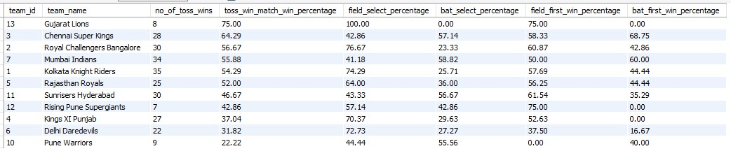

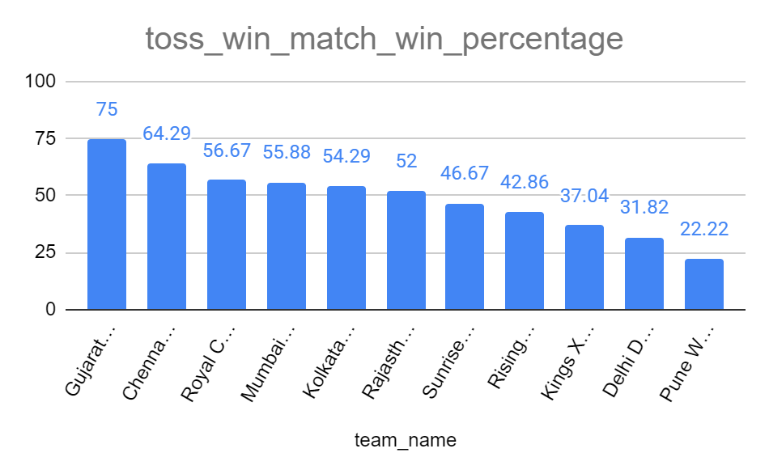

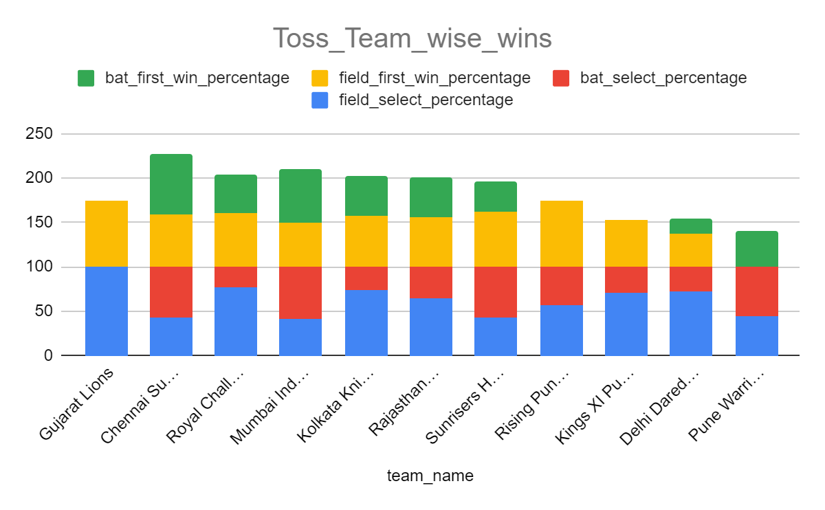
We can see that some teams like CSK, MI & SRH prefer to select bats first.
Some teams like Gujarat Lions, RCB, KKR and DD prefer to field first.
But in general, those who field first have a slightly better percentage of winning those matches.
Query:
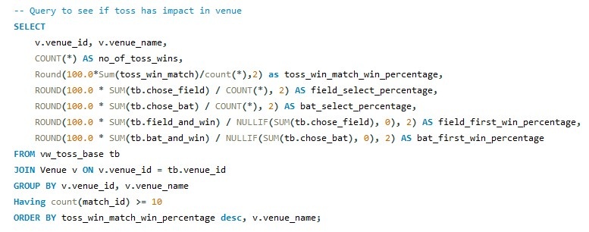

Output:
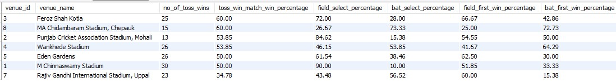
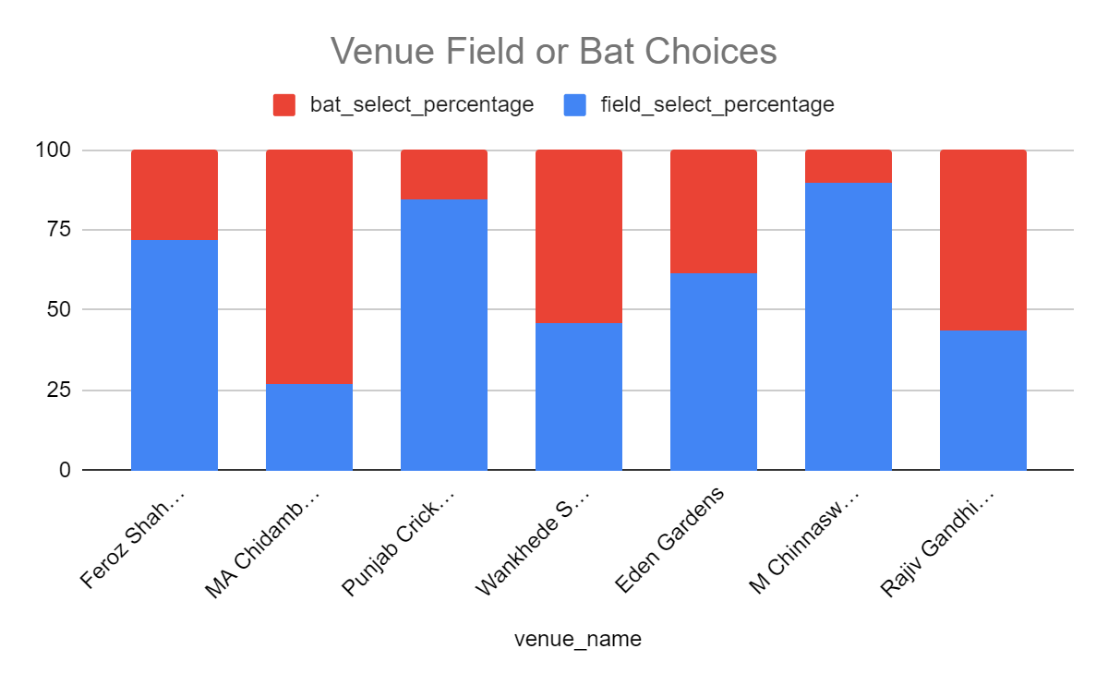
From the above chart we can see that the preferred choice of teams to bat first / field first is dependent on venues.
Some Venues like Chidambaram, Wankhede, Uppal are top choices to bat first and ChinnaSwamy, Punjab, Feroz Shah stadiums have top choices to field first.
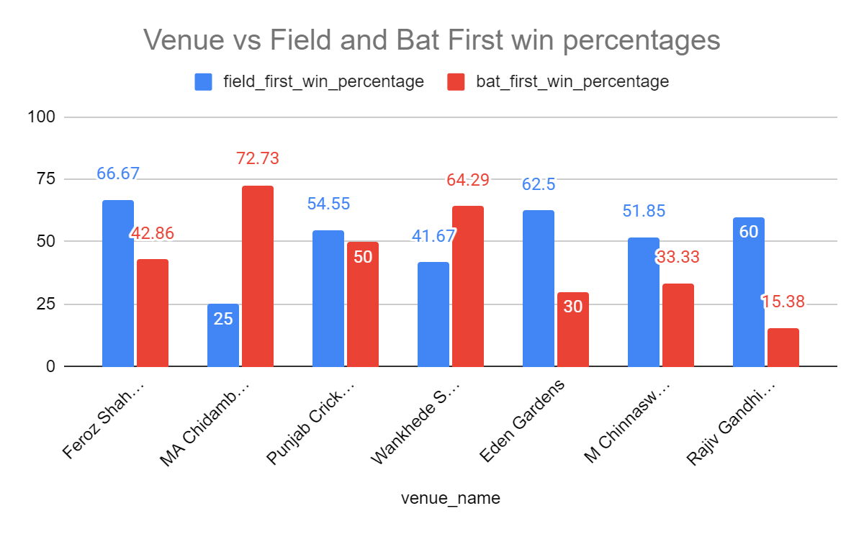
The above chart shows some stadiums have clear advantages for winning when chosen Bat First or Field First.
Since RCB’s home ground is Chinnaswamy Stadium, fielding first and chasing the runs has a higher probability of winning the match.
- Suggest some of the players who would be best fit for the team.
The following analysis identifies players best suited for the team based on their consistent batting contributions, wicket-taking ability, and overall impact across recent seasons.

I. Batsmen (Total Runs + Strike Rate + Batting Average): This analysis focuses on identifying top-performing batsmen by evaluating their total runs and strike rate, and batting average ensuring the selection of players who not only score consistently but also maintain an effective scoring pace, which is crucial for building a strong and balanced team.

Query:
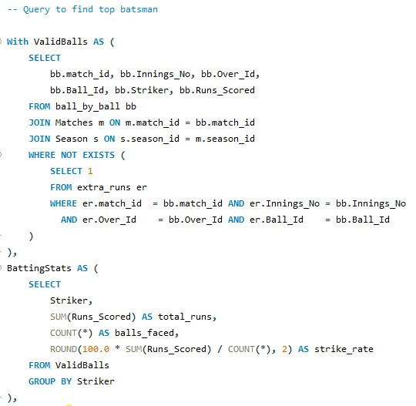
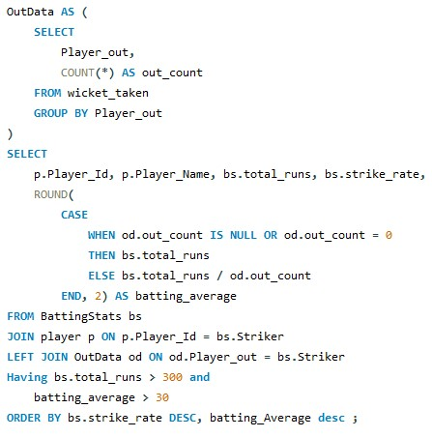

This query identifies batsmen who are best suited for team selection by combining three critical performance dimensions:
- High strike rate – players who score runs quickly and apply pressure on the opposition.
- Strong batting average – players who are consistent and less prone to early dismissals.
- Sufficient match exposure – ensured by a minimum total runs threshold.
By filtering players with more than 300 total runs and a batting average above 30, the analysis eliminates unreliable performers.
The final ordering by strike rate prioritizes players who can maximize scoring efficiency while maintaining consistency.
Output:

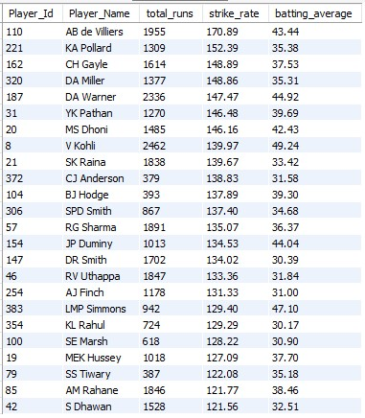

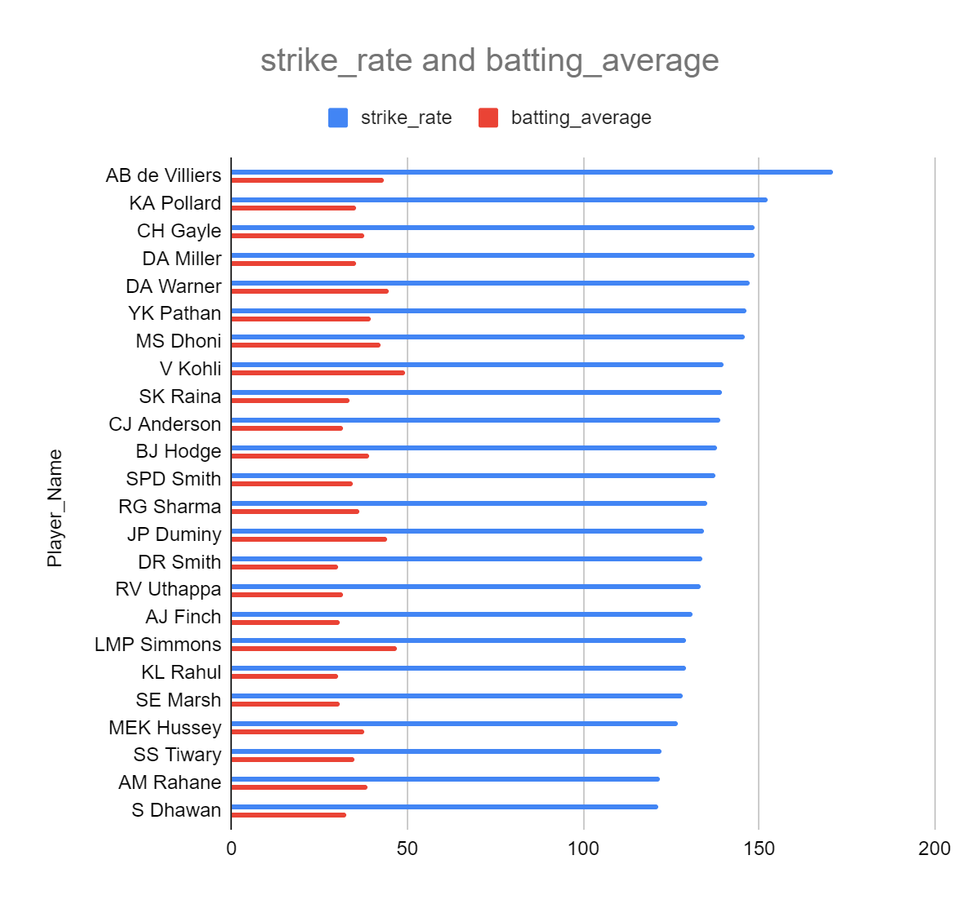
As a result, players like AB de Villiers, David Warner, Virat Kohli, and Chris Gayle emerge as ideal candidates who combine explosiveness, reliability, and experience, making them strong fits for the team.
II. Top Bowlers (Total Wickets + Economy_rate + Bowling Average):
This analysis was performed to identify the most effective bowlers by evaluating both their total wicket-taking ability and their consistency across matches. While total wickets indicate long-term impact, Economy_rate and Bowling Average per match highlight reliability and match-winning potential, which are critical for selecting bowlers who can consistently influence outcomes.
Query:
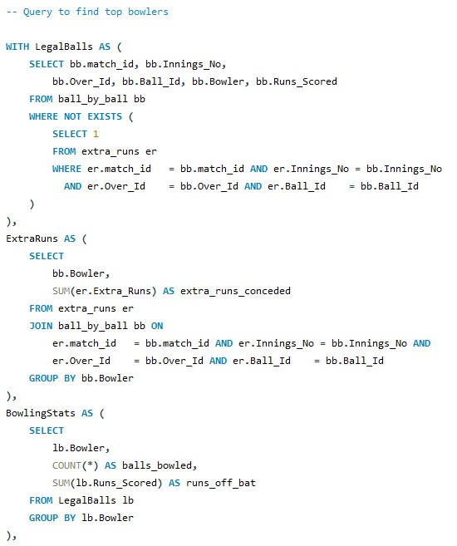

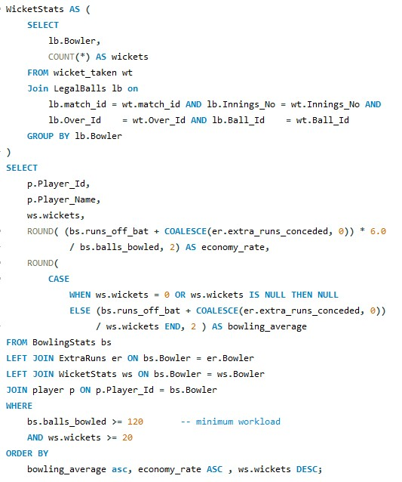
This query identifies bowlers who are best suited for team selection by balancing wicket-taking ability, run control, and efficiency.
By enforcing minimum thresholds on balls bowled and wickets taken, it removes statistical noise and part-time bowlers.
The bowling average captures how efficiently a bowler converts runs conceded into wickets, while the economy rate measures their ability to restrict scoring.
Ordering by bowling average, economy rate, and wickets ensures the selected bowlers provide maximum impact per run while maintaining control and experience.

Output:
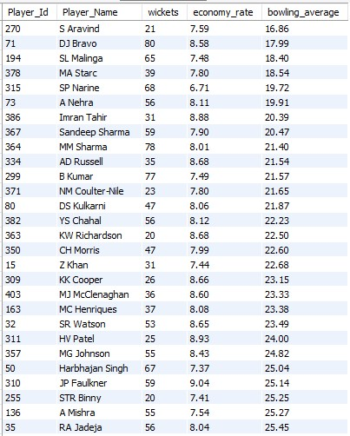
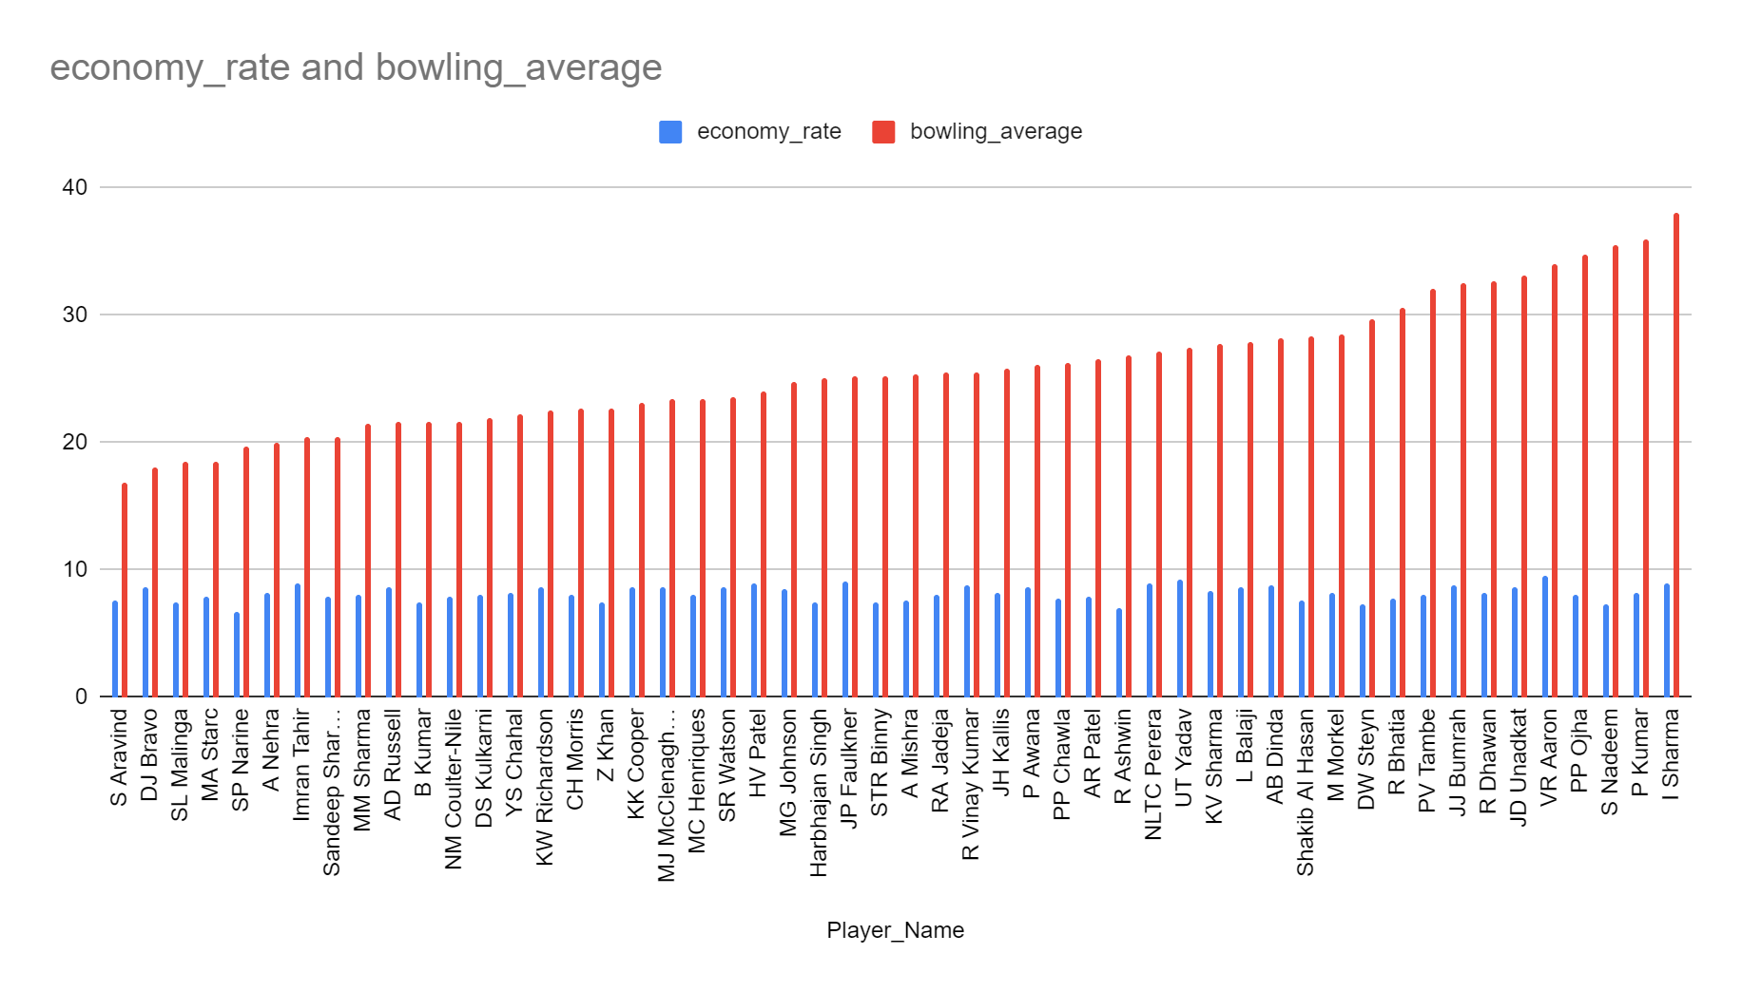
As a result, players such as DJ Bravo, SL Malinga, SP Narine, Bhuvneshwar Kumar, and Jasprit Bumrah emerge as ideal candidates who can both take wickets and apply sustained pressure, making them strong fits for the team.

- What are some of the parameters that should be focused on while selecting the players?
Separate analytical frameworks are designed for batsmen and bowlers to ensure role-specific evaluation.

Batsman Selection Parameters:
Strike Rate
Strike rate measures how quickly a batsman scores runs per 100 balls. It is a key indicator of scoring impact, especially in limited-overs formats where accelerating the scoring rate is critical. A higher strike rate reflects a batsman’s ability to put pressure on the opposition and change the momentum of the game. In this analysis, strike rate is calculated using only legal deliveries to ensure accuracy.
Batting Average
Batting average represents the number of runs scored per dismissal. It indicates a batsman’s consistency and reliability. While strike rate captures aggression, batting average ensures that the selected players are not overly risky and can sustain innings. Players with a higher batting average are less prone to frequent failures and provide stability to the batting lineup.
Total Runs
Total runs scored reflect long-term performance and experience. This parameter ensures that player selection is not influenced by short-term or one-off performances. A minimum total runs threshold is applied to remove statistical noise and ensure that selected players have contributed consistently over multiple matches.
Combined Interpretation for Batsmen
A batsman is considered suitable for team selection if a balance is maintained between scoring impact, consistency, and reliability. High strike rate ensures aggression, a healthy batting average ensures consistency, and sufficient total runs confirm long-term performance.
Bowler Selection Parameters:
Wickets Taken
Wickets taken measure a bowler’s ability to break partnerships and create match-changing moments. This parameter helps identify bowlers who can apply attacking pressure. A minimum wicket threshold is applied to exclude part-time or occasional bowlers.
Economy Rate
Economy rate represents the number of runs conceded per over. It reflects a bowler’s ability to control the flow of runs. This parameter is particularly important in pressure situations such as powerplay and death overs. Extra runs conceded by the bowler are included in total runs conceded, while illegal deliveries are excluded from the ball count to maintain cricket-accurate calculations.
Bowling Average
Bowling average measures the number of runs conceded per wicket. It indicates efficiency in converting runs conceded into wickets. A lower bowling average signifies a higher impact per run and helps identify bowlers who provide maximum value to the team.
Balls Bowled
Balls bowled represent workload and experience. This parameter ensures that bowling performance is evaluated over a meaningful sample size. A minimum threshold is applied to eliminate results based on limited appearances and to ensure consistency and reliability.
Combined Interpretation for Bowlers
A bowler is considered suitable for selection if strong wicket-taking ability is combined with disciplined run control and efficiency. Adequate workload further ensures that the performance is sustainable and reliable over time.
Data Modeling Considerations:
To ensure analytical accuracy, legal and illegal deliveries are treated separately. Extra runs are included in runs conceded but excluded from the ball count. Ball-by-ball data is used instead of match-level aggregates to improve precision. Threshold-based filtering is applied to remove statistical noise and improve the reliability of results.
Conclusion:
Player selection should be based on a balanced evaluation of impact, consistency, efficiency, and reliability rather than a single performance metric. By applying cricket-specific rules and workload thresholds, this data-driven framework identifies players who contribute effectively and consistently to the team. This approach ensures objective, transparent, and defensible player selection decisions.
- Which players offer versatility in their skills and can contribute effectively with both bat and ball? (can you visualize the data for the same)

To identify players who offer versatility and can contribute effectively in both batting and bowling, a data-driven approach is used by combining individual batting and bowling performance analyses. Instead of evaluating all-rounders subjectively, measurable performance indicators are applied to ensure consistency, impact, and reliability.
As a foundation, the outputs of the previous analytical queries for batsmen and bowlers are saved as database views named `top_batsmen` and `top_bowlers`. Storing these results as views enables reusable, modular analysis and ensures consistency across multiple selection-related questions.
Batting Evaluation Criteria:
The `top_batsmen` view identifies players who contribute meaningfully with the bat based on the following conditions.
Only legal deliveries are considered by excluding balls recorded in the `extra_runs` table. This ensures strike rate calculations reflect true batting effort.
Players are required to have scored more than 200 total runs, which filters out players with insufficient batting exposure.
A minimum batting average of 20 is enforced to ensure consistency and eliminate high-risk, low-return performers.
Strike rate is calculated to measure scoring impact and attacking ability.
These filters ensure that selected players are not only aggressive scorers but also reliable contributors over a reasonable sample size.
Bowling Evaluation Criteria:
The `top_bowlers` view evaluates bowling performance using cricket-accurate calculations and workload thresholds:
Only legal deliveries are counted toward balls bowled, while extra runs conceded (wides, no-balls) are included in runs conceded.
Players must have bowled at least 120 legal deliveries, ensuring adequate workload and reliability.
A minimum wicket threshold of 10 wickets is applied to identify genuine bowling contributors rather than part-time options.
Economy rate is calculated using total runs conceded per over to measure run control.
Bowling average is calculated to assess efficiency in converting runs conceded into wickets.
This ensures that bowlers included in the view demonstrate both discipline and wicket-taking ability.
Query:
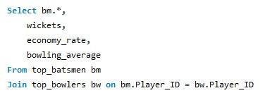
Identifying Versatile Players:
To answer the question of versatility, the `top_batsmen` and `top_bowlers` views are joined on `Player_Id`. This intersection highlights players who simultaneously meet the batting and bowling performance criteria.
Players appearing in the final result set are those who:
- Score runs consistently with a healthy strike rate and batting average
- Take wickets regularly while maintaining acceptable economy and bowling averages
- Have sufficient workload in both disciplines, ensuring reliability
Output:
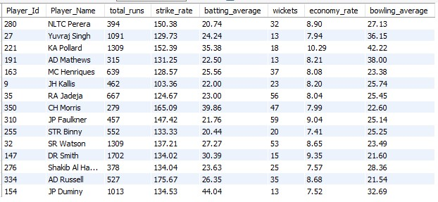

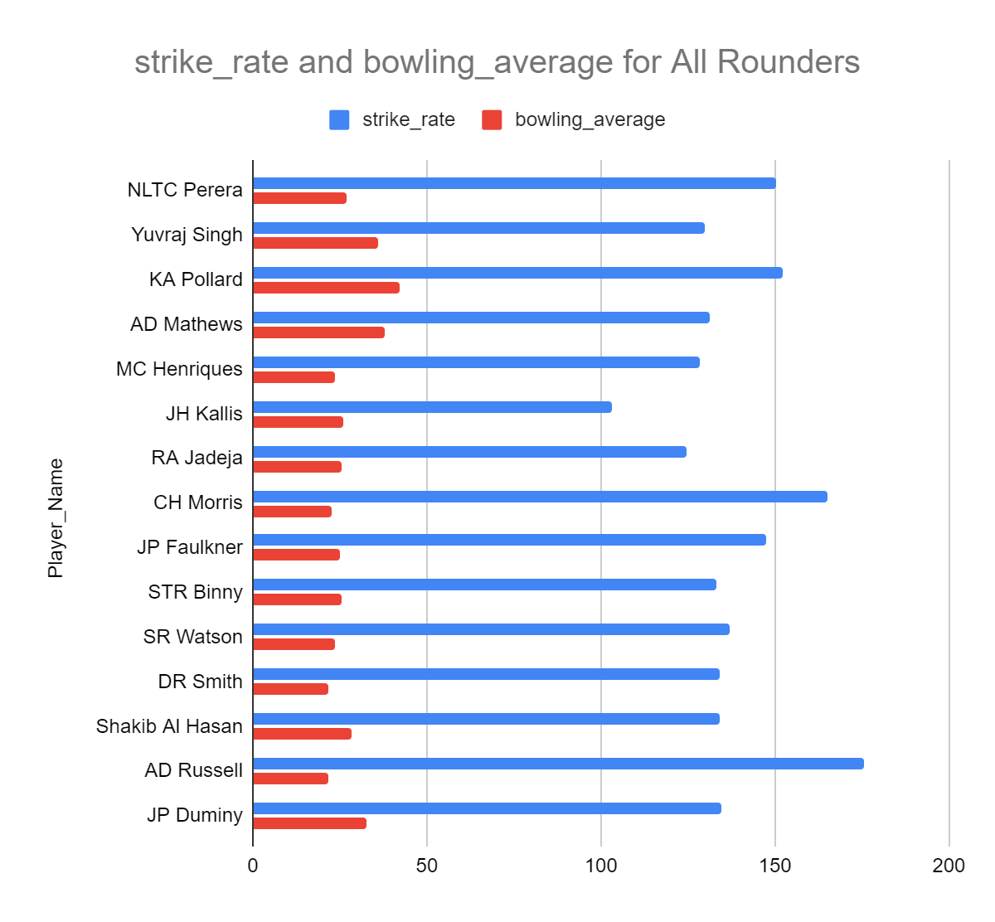
Such players provide flexibility in team composition by contributing in multiple phases of the game. They strengthen the batting lineup while also offering bowling options, making them valuable assets in limited-overs formats where balance and adaptability are critical.
Conclusion
By saving role-specific performance metrics as views and applying well-defined filtering conditions, versatile all-round players are identified objectively. This approach ensures that selected players contribute meaningfully with both bat and ball, offering tactical flexibility and improved team balance. The use of reusable views also makes the analysis scalable, consistent, and easy to extend for future selection decisions.

- Are there players whose presence positively influences the morale and performance of the team? (justify your answer using visualization)
“Morale and influence” are subjective and cannot be measured directly from data. However, player influence can be strongly inferred using match-impact indicators, such as:
- Man of the Match awards
  - Indicates decisive individual contributions in winning matches.
  - Often reflects leadership, clutch performance, and confidence boost to the team
Query:
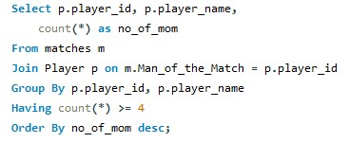
Output:
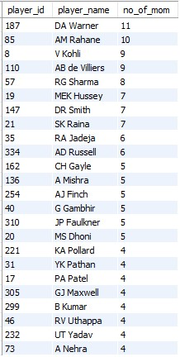
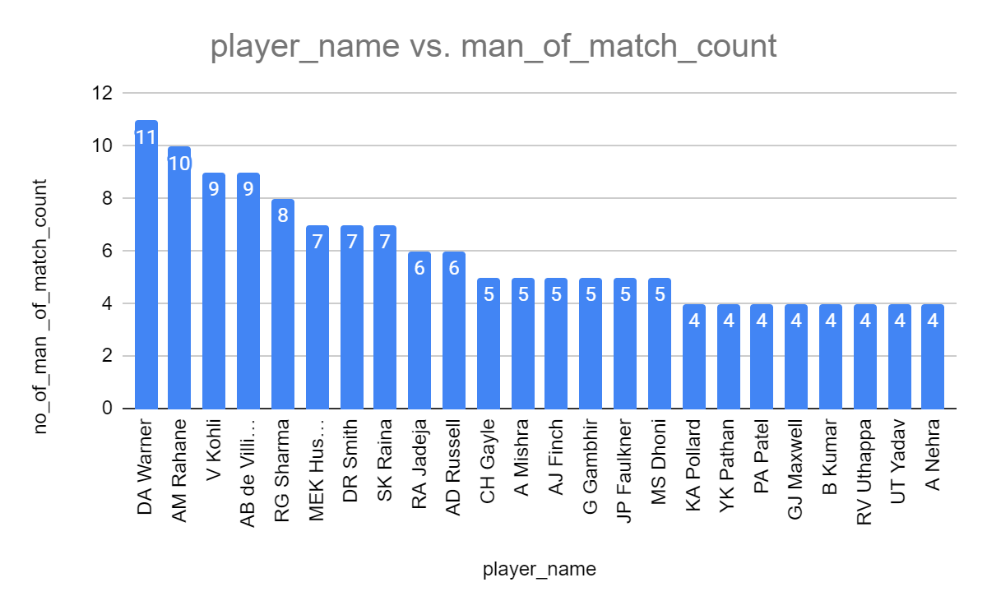
- Team win percentage when the player is present
  - If a team consistently wins more matches when a specific player is in the playing XI, it suggests positive influence

Query:
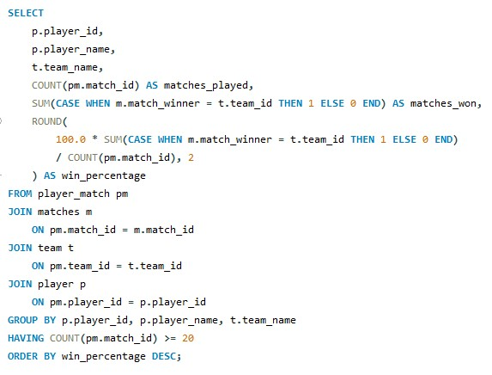
This query evaluates a player’s influence on team success by measuring how often the team wins when that player is part of the playing XI. It joins player participation data with match results and team information to calculate the total matches played and the number of matches won for each player–team combination.
The win percentage is then derived as the proportion of matches won out of matches played, ensuring statistical reliability by filtering players who have participated in at least 20 matches. Players with higher win percentages are interpreted as having a stronger positive impact on team performance, which can be used as a data-backed proxy for on-field influence and morale contribution.

Output:
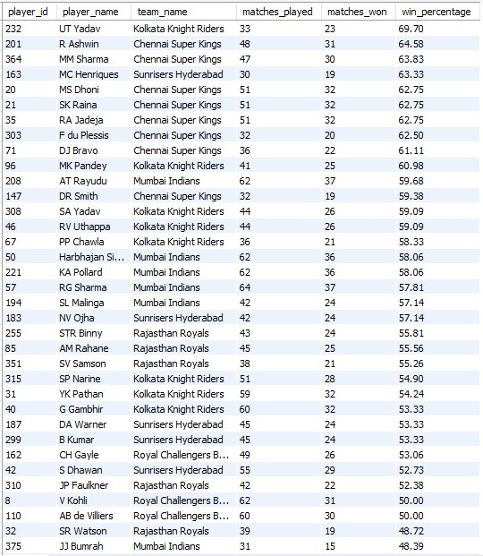

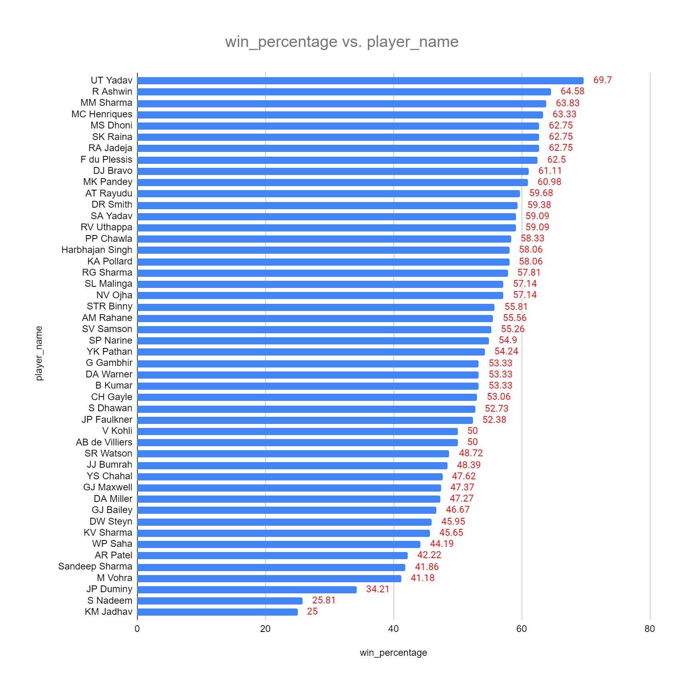
Conclusion
Players such as David Warner, MS Dhoni, Rohit Sharma, Suresh Raina, and AB de Villiers consistently appear at the top in two critical indicators: Man of the Match awards and team win percentage when they are part of the playing XI. A high Man of the Match count reflects repeated match-winning contributions under pressure, while a strong win percentage shows that teams tend to perform better when these players are present.Using these measurable proxies, we can objectively justify player influence using data.
- What would you suggest to RCB before going to the mega auction?
Before going into the mega auction, RCB should approach team building with structure and role clarity rather than star-chasing. The analysis of performance metrics, win percentage, and Man of the Match trends highlights several clear strategic priorities.
RCB should retain and build around proven match-winners instead of focusing only on high-profile names. Players such as Virat Kohli already provide batting stability and leadership, so the emphasis should be on surrounding him with consistent impact players who historically improve the team’s win percentage when they are part of the playing XI.
A key priority should be investing in a strong Indian core, particularly Indian bowlers and all-rounders. Successful teams demonstrate that Indian players who can bowl in the powerplay and death overs, or contribute in both batting and bowling, offer greater balance and long-term stability compared to teams that rely heavily on overseas players.
RCB should also aggressively target genuine all-rounders. Players who contribute with both bat and ball improve team flexibility across different match situations and reduce overdependence on specialists. Even moderate-impact all-rounders often strengthen multiple phases of the game and positively influence overall results.
Another critical area of focus must be death-over bowling. Historically, RCB has struggled to contain runs at the end of innings. Bowlers with proven ability to maintain a lower economy rate and take wickets under pressure should be prioritized over bowlers selected purely for pace or reputation.
Additionally, RCB should look for players with demonstrated influence, measured through Man of the Match awards and higher team win percentages when they are present. Such players often bring leadership, composure, and clutch performances, which directly impact team morale and performance in high-pressure matches.
Finally, RCB should avoid overpaying for single-skill players and instead adopt a role-based auction strategy. This includes securing a powerplay enforcer, a middle-order stabilizer, a finisher, at least two reliable death-over bowlers, and a spin option who can contribute with the bat. Teams that succeed in mega auctions typically win through balance and consistency rather than individual brilliance.
Overall, RCB’s auction strategy should shift away from big names and focus on impact, balance, and role clarity, supported by data-driven decision-making rather than reputation alone.
- What do you think could be the factors contributing to the high-scoring matches and the impact on viewership and team strategies
High-scoring matches in the league are influenced by a combination of venue characteristics, phase-wise scoring patterns, and evolving team strategies. Data-driven analysis of venue-wise average runs per match and team-wise powerplay and death-over performance provides clear insights into why certain matches consistently produce large totals.
Query:
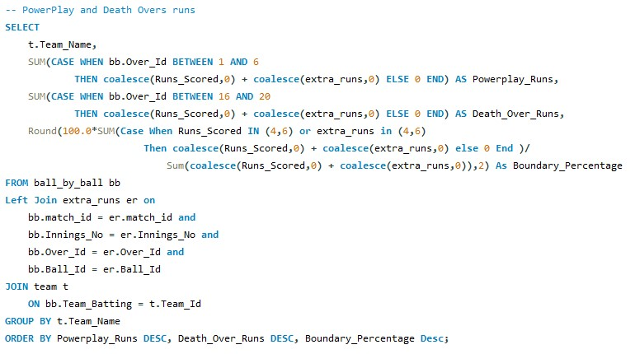
Output:
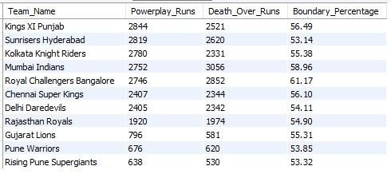
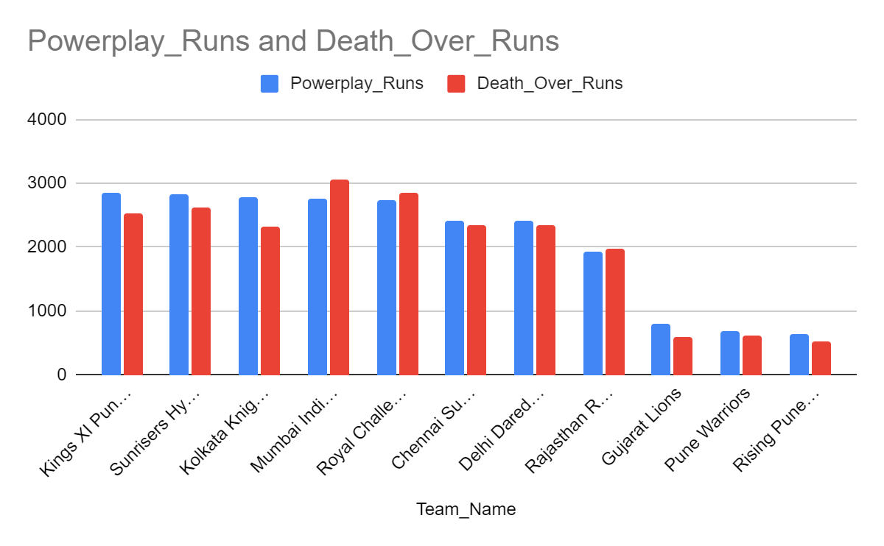

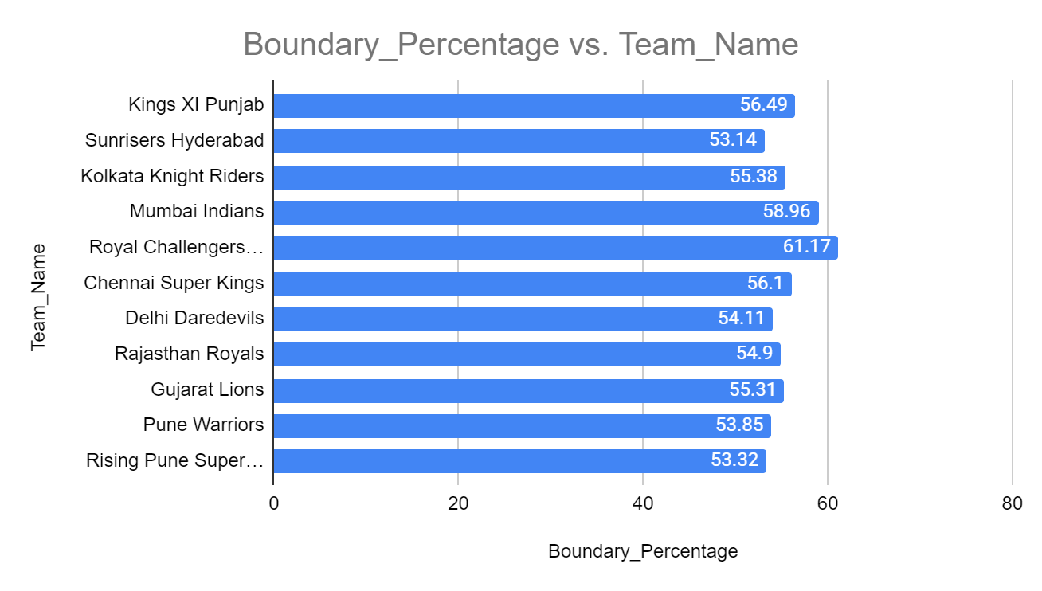
Phase-wise scoring trends further explain the rise in match totals. Analysis of powerplay and death-over runs shows that teams like Royal Challengers Bangalore, Mumbai Indians, Sunrisers Hyderabad, and Kolkata Knight Riders score heavily in both the first six overs and the final five overs. High powerplay runs indicate aggressive starts driven by fielding restrictions, while strong death-over totals reflect the presence of finishers and bowlers struggling to contain scoring under pressure. When teams consistently maximize both phases, match totals increase substantially.
Boundary percentage also has a direct impact on scoring intensity. Teams with higher boundary percentages rely less on strike rotation and more on clearing the ropes, which accelerates scoring rates. This reflects the modern batting approach focused on power-hitting, innovative shot-making, and calculated risk-taking rather than traditional anchor-based innings.

Query:
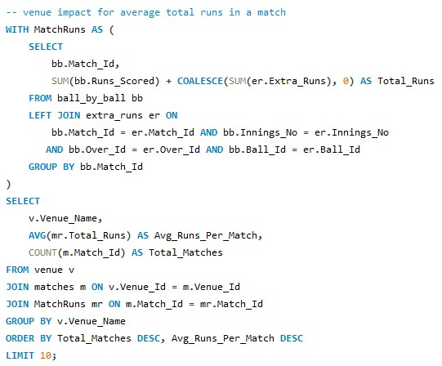
Output:
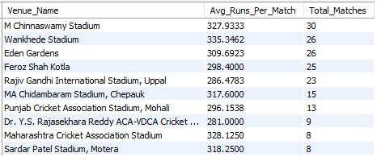
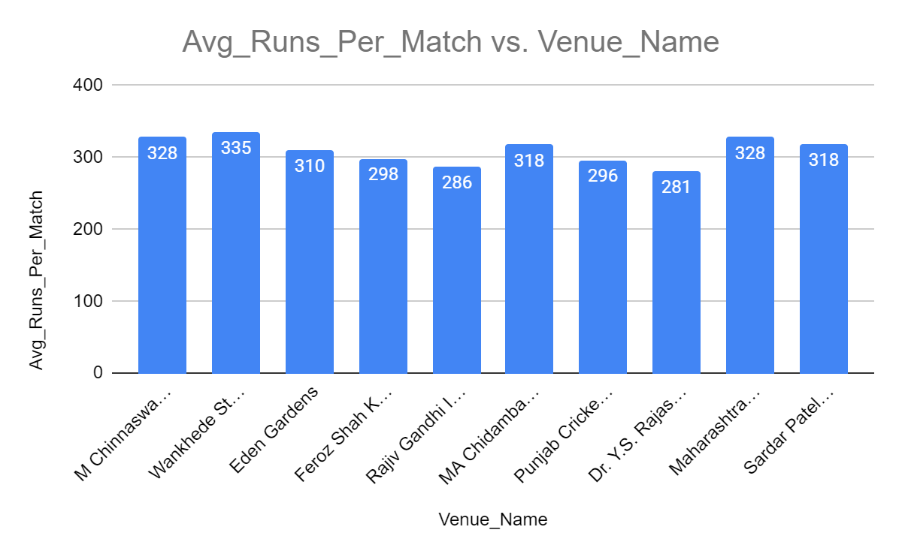
Venue conditions play a major role in high-scoring games. Stadiums such as M Chinnaswamy Stadium, Wankhede Stadium, Eden Gardens, and Sardar Patel Stadium record significantly higher average runs per match. These venues are characterized by flat pitches, consistent bounce, shorter boundaries, and fast outfields, which reduce margin for error for bowlers. When such conditions are present, teams are encouraged to bat aggressively from the early overs, knowing that run-scoring opportunities are high and defensive bowling becomes difficult.
From a viewership perspective, high-scoring matches significantly enhance entertainment value. Frequent boundaries, rapid momentum shifts, and close run chases increase fan engagement and keep audiences invested throughout the match. Batting-friendly venues combined with aggressive team strategies contribute to record totals and dramatic finishes, which are commercially attractive and boost overall viewership.
These scoring patterns also reshape team strategies. Teams now prioritize players who can exploit batting-friendly conditions, especially powerplay enforcers and death-over finishers. On the bowling side, there is increased emphasis on variation, execution under pressure, and specialist death bowlers rather than raw pace alone. Squads are increasingly built with deeper batting lineups and flexible all-rounders to sustain aggression across all phases of the innings.
Overall, high-scoring matches are the result of favorable venues, aggressive phase-wise scoring, and evolving tactical approaches. While they enhance fan experience and commercial appeal, they also force teams to innovate continuously in squad composition and match strategy to remain competitive in a batter-dominated environment.
- Analyze the impact of home-ground advantage on team performance and identify strategies to maximize this advantage for RCB.
Home-ground advantage plays a significant role in influencing team performance by offering familiarity with pitch conditions, boundary dimensions, crowd support, and tactical predictability. An analysis of Royal Challengers Bangalore’s matches at M Chinnaswamy Stadium highlights clear performance patterns that can be leveraged to improve future outcomes.
Query:
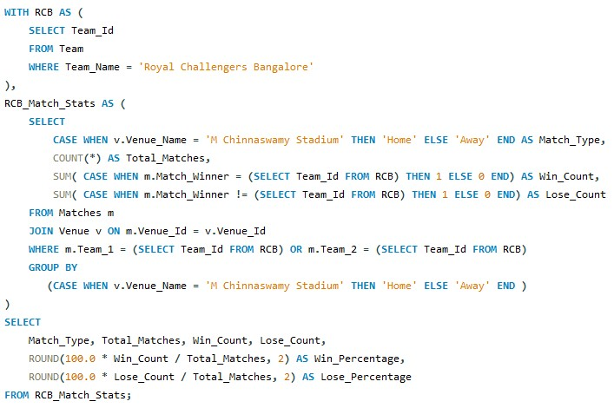
Output:
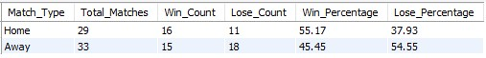
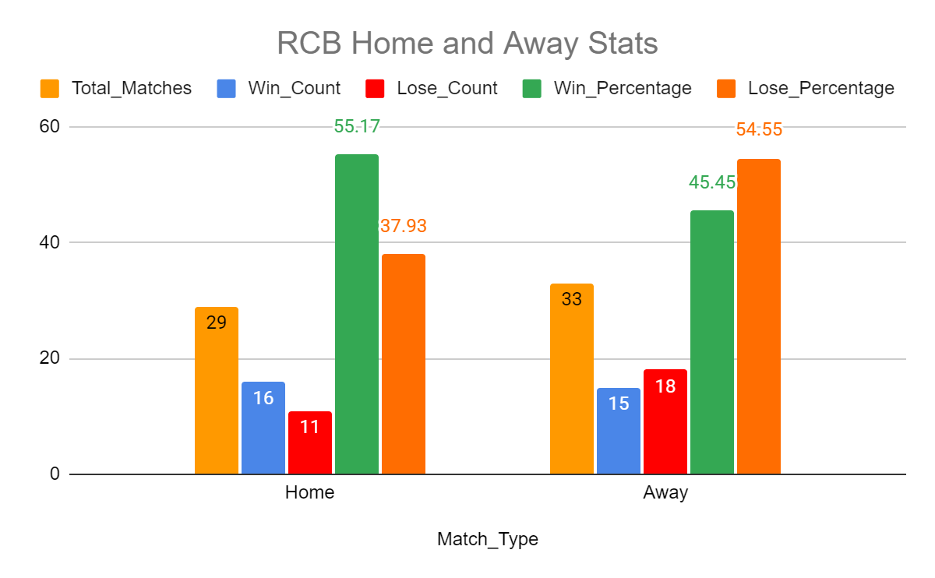
The home versus away performance analysis shows that RCB has a higher win percentage at M Chinnaswamy Stadium compared to away venues. At their home ground, RCB has won 16 out of 29 matches, resulting in a win percentage of 55.17 percent. In contrast, away matches show a relatively lower and more inconsistent success rate across multiple venues. This indicates that Chinnaswamy provides conditions that suit RCB’s strengths better than most away grounds, confirming the presence of a measurable home-ground advantage.
Query:
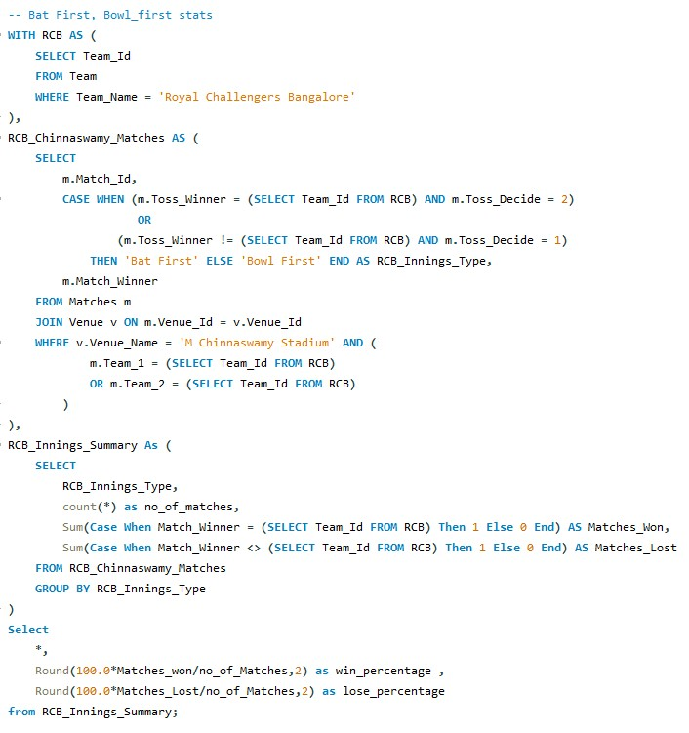

Output:
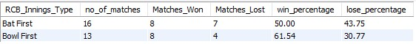
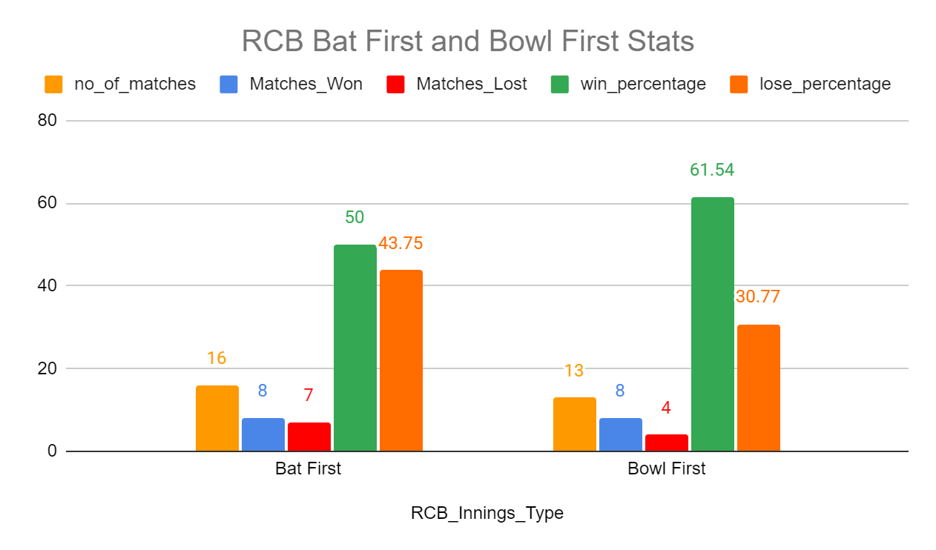
The batting first versus bowling first analysis at Chinnaswamy Stadium provides deeper strategic insight. When RCB bowls first, the win percentage increases to 61.54 percent, compared to a 50 percent win rate when batting first. This suggests that chasing is a more effective strategy at this venue, likely due to factors such as dew, predictable bounce, and the ability to pace run chases on a high-scoring ground. This finding directly supports a data-driven toss strategy where RCB should prefer to field first whenever conditions allow.
Query:
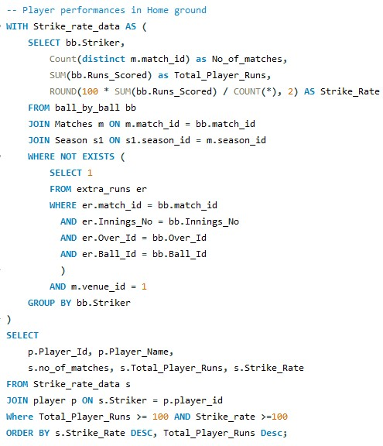
Output:
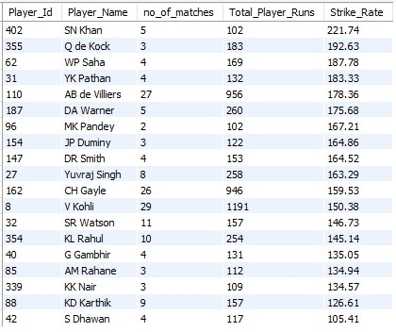
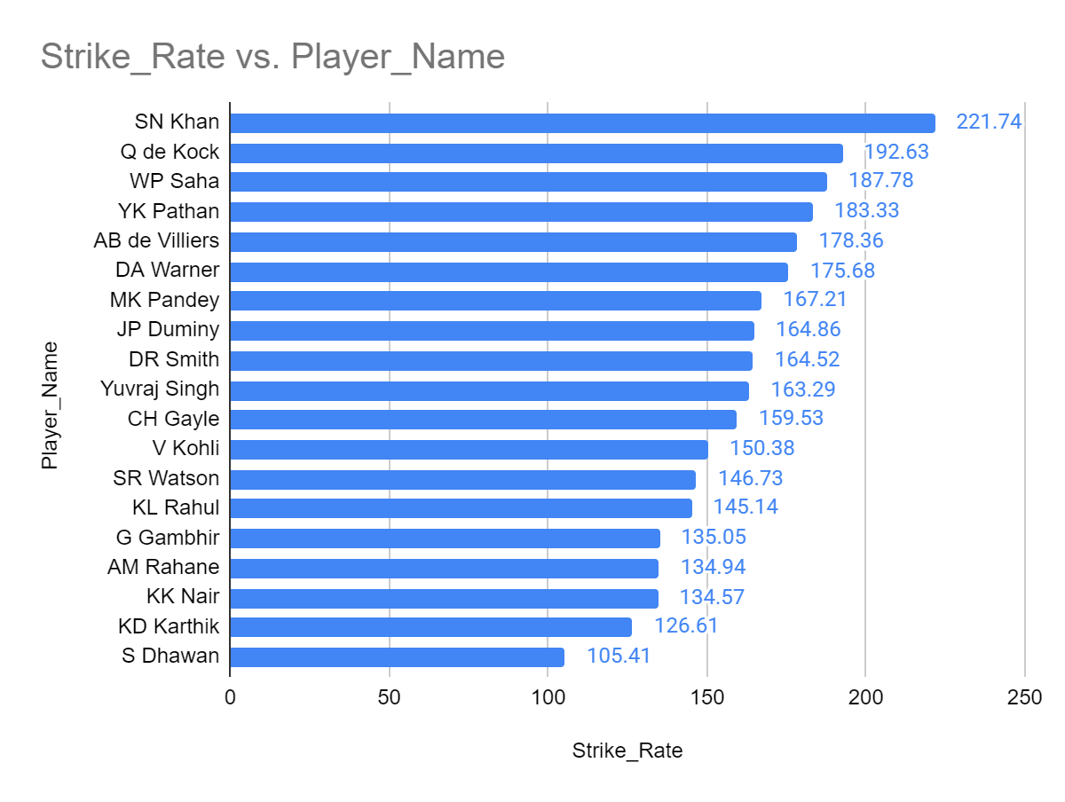
Individual player performance analysis further strengthens the understanding of home advantage. Batting statistics at Chinnaswamy Stadium reveal that several players maintain high strike rates and significant run contributions at this venue. Players such as AB de Villiers, Virat Kohli, Chris Gayle, and David Warner combine high run volume with aggressive scoring rates, indicating that they are well suited to exploit the batting-friendly conditions of the stadium. These players should be prioritized in home matches as core batting contributors.

Query:
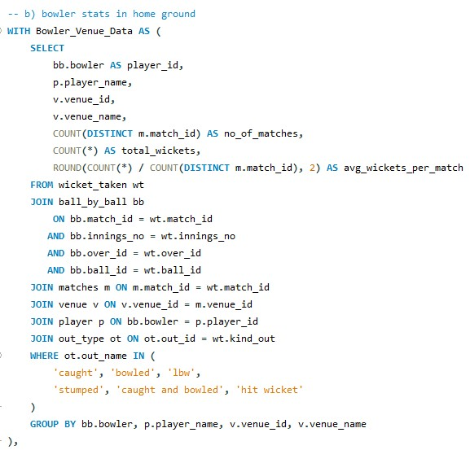
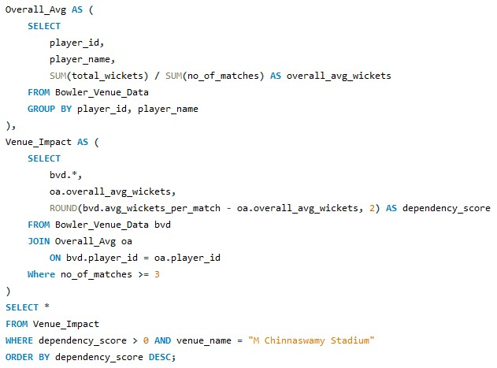
Output:
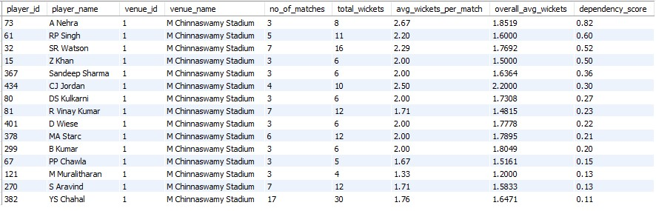
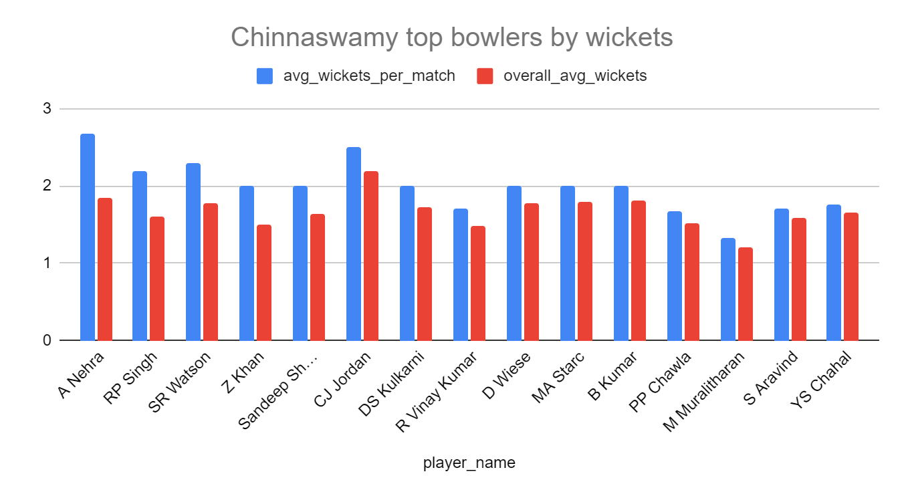
Bowling performance at the home ground reveals another critical insight. The venue-dependency analysis shows that certain bowlers perform better at Chinnaswamy than their overall career averages. Bowlers like Anrich Nortje, RP Singh, Shane Watson, and Zaheer Khan display positive dependency scores, meaning they take more wickets per match at Chinnaswamy compared to other venues. This suggests that despite the ground’s reputation as batting-friendly, bowlers who rely on pace variation, hard lengths, or accuracy can still be highly effective here.
Conclusion:
Combining these findings leads to several clear strategic recommendations. RCB should continue to build batting lineups around aggressive, high-strike-rate players who can fully utilize the short boundaries. Toss decisions should favor bowling first to maximize win probability. Team selection for home matches should prioritize bowlers with proven venue-specific effectiveness rather than relying solely on reputation or raw pace. Finally, squad planning should differentiate between home and away combinations instead of adopting a one-size-fits-all playing XI.
In conclusion, the queries and outputs collectively demonstrate that RCB does benefit from home-ground advantage at M Chinnaswamy Stadium. By aligning toss decisions, player selection, and tactical planning with venue-specific performance data, RCB can systematically maximize this advantage and improve consistency in home results.
- Come up with a visual and analytical analysis of the RCB's past season's performance and potential reasons for them not winning a trophy.
Season wise total matches played win and loss percentages of RCB
Query:
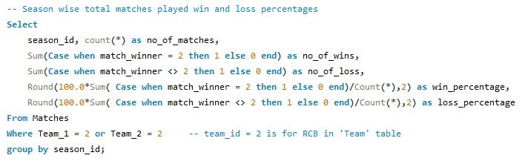
Output:
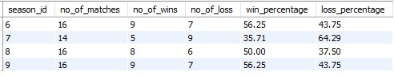
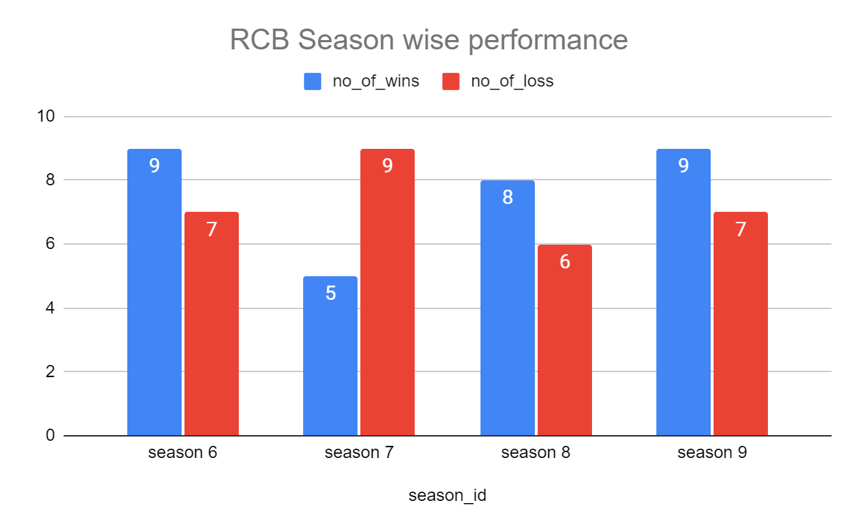
We can see that RCB won more than 50% of matches they played in Seasons 6, 8,9. In season 7 it has under performed.
Created some views to do some analysis:
The below view shows match data of all the playoffs in all the seasons.
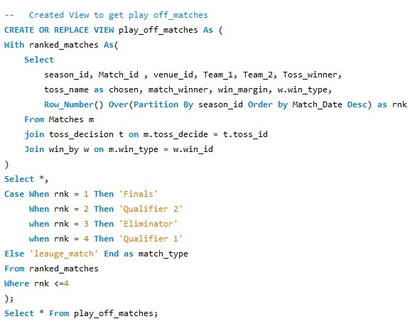
The below view filters the play_off_matches view to show RCB matches
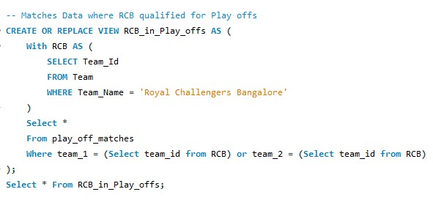

Output:
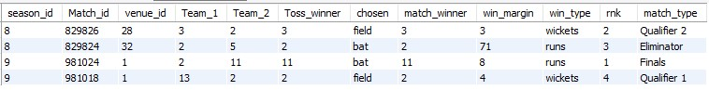
We can notice that RCB got into the playoffs in season 8 and season 9.
In Season 8 it reached up to Qualifier 2 and lost to CSK (team_id = 3)
In Season 9 it reached Final and lost to SRH (team_id = 11)

Query:
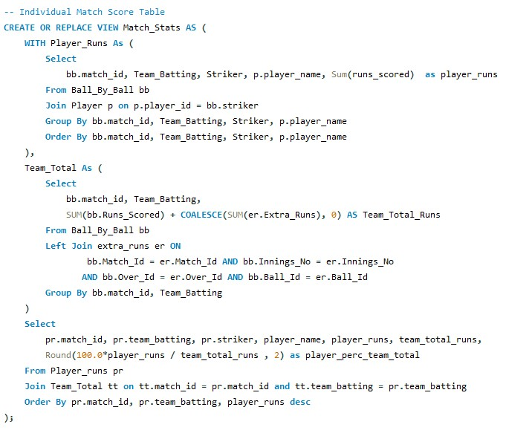
The above view generates Match stats like how much each batsman has scored and his contribution percentage to team total runs.
The below query shows the Qualifier 2 match data
Query:
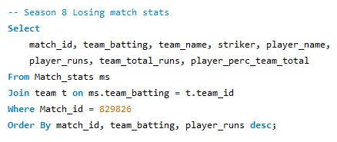
Output:
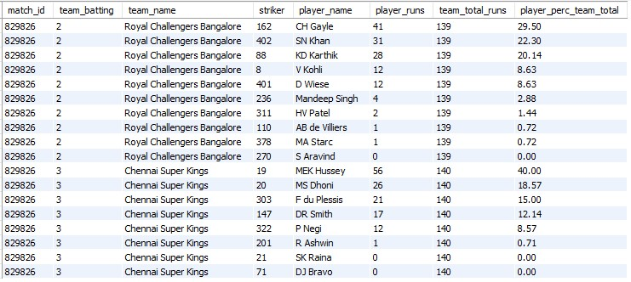
In season 8, in 3 matches that RCB has played against CSK it has lost all 3 of them. In this particular deciding match we can see the top contributors of RCB like Virat has scored only 12, AB de Villiers has scored only 1 run and CHris Gayle only 41. It is clear the RCB top order struggled to score runs against CSK Bowlers.
Whereas CSK Batsmen like Hussey (56), MSD(26), F du Plessis (21) Smith(17) with consistent contributions have chased the low target.

Now let us see the stats for Season 9 final between RCB and SRH
Query:
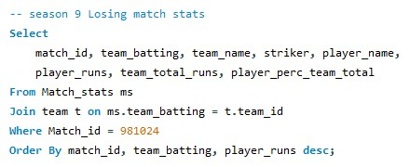
Output:
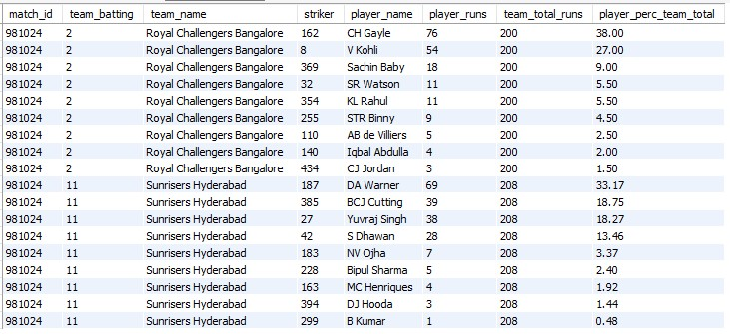
Batting First SRH has put up a good total of 208 with major contributions from Warner(69), Cutting(39), Yuvraj Singh(38), Dhawan(28).
RCB couldn't chase the target even after Chris Gayle scoring 76 and Virat Kohli scoring 54. Because the rest of the batsmen couldn’t even score more than 20 runs.
This shows how RCB batting line up is not consistent enough and only depending on top 3,4 performers to win the matches.

- How would you approach this problem, if the objective and subjective questions weren't given?
I would break the approach into five clear phases:
1. Understand the Business / Domain Context
Before writing any SQL, I would first clarify what success means in the context of IPL analytics.
Key guiding questions:
- What defines team success? (wins, trophies, consistency, playoff qualification)
- What are the controllable factors? (batting depth, bowling strength, toss decisions, venue effects)
- What are the uncontrollable factors? (pitch, opposition strength, randomness)
For RCB specifically, the high-level business question becomes:
Why has RCB not converted strong seasons into trophies, and where are the structural gaps?
This framing naturally leads to performance, consistency, and dependency analysis.
2. Explore the Data Structure (Data Familiarization)
Before analysis, I would audit the schema to understand:
- Granularity: ball-level vs match-level vs season-level
- Fact tables: ball_by_ball, matches, wicket_taken
- Dimension tables: player, team, venue, season, out_type
Initial exploratory queries would include:
- Seasons available
- Matches per season
- Teams participating per season
- Missing values, spelling inconsistencies, or data quality issues
This step ensures correct joins, cricket-rule accuracy, and avoids wrong assumptions.
3. Define Core Performance Metrics (KPI Discovery)
Without predefined questions, I would derive KPIs organically from the data:
Team-level KPIs
- Win percentage per season
- Home vs away win percentage
- Playoff qualification frequency
- Performance in knockout matches
- Toss decision impact
Batting KPIs
- Runs per match
- Strike rate (legal balls only)
- Dependency on top-order batsmen
- Collapse frequency (low middle-order contribution)
Bowling KPIs
- Wickets per match
- Economy rate (including extras)
- Death-over effectiveness
- Venue-specific bowling success
These KPIs emerge naturally from asking:
What wins matches consistently in T20 cricket?
4. Drill Down Using Progressive Hypotheses
Instead of isolated questions, I would follow a top-down hypothesis flow:
Hypothesis 1:
“RCB is inconsistent across seasons”
→ Validate with season-wise win percentages.
Hypothesis 2:
“RCB depends heavily on a few players”
→ Test using contribution % of top 3 batsmen.
Hypothesis 3:
“RCB struggles in high-pressure matches”
→ Analyze playoff and final match performances.

Hypothesis 4:
“RCB’s bowling is not match-winning”
→ Compare wickets per match and death-over stats.
Each hypothesis leads to new queries, not pre-written questions.
5. Convert Insights into Strategy & Storytelling
Once patterns emerge, I would:
- Use visuals (bar charts, trend lines, contribution charts)
- Compare RCB with successful teams (CSK, MI)
- Translate numbers into actionable strategy

For example:
- High dependency index → need middle-order stability
- Poor death bowling → need specialists, not generalists
- Better chasing record at home → toss strategy alignment
This step transforms raw SQL outputs into decision-making insights, which is the real goal of analytics.
Final Summary
If objective and subjective questions were not provided, the approach would be:
- Start with business understanding
- Explore the data model deeply
- Let KPIs emerge naturally
- Follow hypothesis-driven analysis
- End with strategy, not just answers
This mirrors how real analytics problems are solved in:
- Sports analytics teams
- Business intelligence roles
- Data analyst interviews
- Consulting case studies

- In the "Match" table, some entries in the "Opponent_Team" column are incorrectly spelled as "Delhi_Capitals" instead of "Delhi_Daredevils". Write an SQL query to replace all occurrences of "Delhi_Capitals" with "Delhi_Daredevils".
There is no table where the “Opponent_Team” column is present.
In given data, there is only one table named Team which has the names of Teams. And it has the correct name “Delhi_Daredevils”.
In case, if it was incorrect, the Query to update it would be:
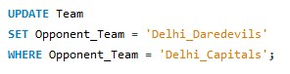
= = = = = = = = = = = = Thank You for reading till the end = = = = = = = = = =

